**IS52018C Software Projects: Project Proposal**

**[example of 70+ work]**

**IS52018C Software Projects**

**A web application for restaurants to bring customers together through translation and imagery**

Contents

Concept Introduction 4

Stakeholder & User Needs: 4

Prior Knowledge & Market Survey: 5

Design 7

UML Diagram updated 10

Use case diagram for customer 12

Sequence Diagrams 13

Sequence diagram customer 13

Sequence diagram chef 14

Sequence diagram admin 15

Prototyping: 16

High Fidelity Prototypes for Customer Side 18

Changes made as a result of client/stakeholder feedback 19

High-Fidelity Prototype for Admin 20

High Fidelity for Chef Side 24

Changes applied for kitchen side: 24

Technical prototypes 26

Functional Specification: 27

Technical Architecture: 27

System Requirements & Technical Specification 28

Purpose 28

Scope 29

Functional requirements 29

Non-Functional Requirements 36

System Overview & Technical Architecture 37

References 38

Ethical audit: 39

Evaluation Plan 40

Project management 41

[Main GANTT Chart for larger task management (M1, M2, M3)](../../../C:/Users/ashik/Desktop/ReportForKatie.docx#_Toc27019852) 42

[Sub-GANTT subdivision of M4 milestones](../../../C:/Users/ashik/Desktop/ReportForKatie.docx#_Toc27019853) 43

Trello for task management 44

Development Methodology: Agile 45

Conclusion 46

Bibliography 47

Appendices 51

Concept Meeting with SugarOverdose Narnia Hotel Attendees: 51

Low fidelity prototypes- customers side 52

Low fidelity prototypes- chef side 55

Low fidelity prototypes- customers side 56

Low Fidelity Meeting with SugarOverdose 60

Reflection on feedback: 60

High Fidelity Meeting with SugarOverdose 61

Decision making: technologies relevant for the Interactive Order System 62

Impactful supervisor meetings 64

Supervisor 12/11/2019 64

Supervisor meeting 15/10/2019 65

Supervisor meeting 29/10/2019 66

# Concept Introduction

The main concept of this project is to provide a web application-based system to enhance the dining experience, order processing and administrative aspect of most culinary businesses, with specific focus on hotel-restaurants. The customers would mainly interact with this system through a tablet1 device placed on their table, the kitchen is able to process the incoming order through a screen at their service, and finally the manager or administrator can query and print incoming sales data for business intelligence. The web app interface on the customer side offers exclusive features such as translation2 and social media interaction. The inspiration for this concept derives from the will to reduce real-life business issues such as communication issues between kitchen staff and foreign customers, waste of logistics and inventory and usage of paper that is susceptible to be misplaced by chefs.

# Stakeholder & User Needs:

All the team members acknowledged that our concept is in line with the interest of a lot of businesses that handle food related services. There has been a scouting process to identify and contact potential stakeholders, which ended up being very successful. SugarOverdose Hotel in Narnia, West London has agreed a professional-academic relationship to assist during the phases of this project, which so far included concept discussions, prototyping discussions and could potentially include testing and piloting. Here is a brief summary of some initial concept consultations with the manager:

* Given the business is close to Heathrow Airport, the clientele has varying nationalities – this reinforced the translation aspect.
* Waiters and waitresses are often asked further details about dishes during breakfast and lunch sessions
* Need for an administrative feature – this aspect has not been included in the initial concept document (M1), but it has been included and approved by the team as part of this report, so will be proceeding into the next stages of the project
* The manager expressed that the inclusion of payment into the system could potentially add an extra layer of productivity.

International Food Bloggers (stakeholders) have also expressed very positive views for our initial concept to create an interactive system where the menu is illustrative with photos and videos of the dishes, with translation options and extra features like “popular dishes of the day”,  “what people around them are eating” and social media feeds of the dishes. The bloggers felt that this product was needed and overdue. They have struggled with not knowing languages and was hindering them from trying certain dishes.

# Prior Knowledge & Market Survey:

One competitor of ours is PunkRockers. They have self-ordering machines which customers can choose between 5 languages, see photos of the food available and pay using card payments. After speaking to a Manager at McDonald’s; she really liked the idea and felt that when McDonald’s first introduced their self-ordering machines (kiosks) it really helped increase the amount of orders specifically amongst tourists that may not understand or speak English as their machines allows translations to 5 different languages. The problems with this tech and system at PunkRockers- “sometimes customers love and miss the interaction with humans, some people are not willing to use the tech offered. In the beginning the investment needed for this tech and system cost a lot of money however in the longer run it is benefitting our company. A main aim is to also make our system be more illustrative so customers can see photos and videos of each item on the menu.

We also started our online research on google, firstly searching what articles recommend the top apps for any restaurant owner. This brought us to many great site listings a minimal of 10 different apps.3 From there we were able to see what restaurant owners are already using and how the market is shaped for apps. We narrowed it down to only looking at apps that was more for customers and less about the restaurant’s backend (inventory or staff schedule). With the select apps we thought were relevant we searched through app store and the google store to see reviews from customers online. Then we searched for tablets that are being used at restaurants already, not a lot of these had many online reviews as the product is very new but we were able to find their features and what awards they had won.4

|  |  |
| --- | --- |
| **Amburapp[5]** | **Pourmybeer[6]** |
| **While this app is for the waiters only and not for the customers, they do have some similar features like:**  **- Sending the orders straight to the kitchen**  **- Allow the meal to be unique and for customers to change items on the menu with ease**  **- Live sales** | **A similar concept but with a bar:**  **- Customers select what they want and the system gives them the beer they want**  **- They have all the info about different beers and the inside ingredients** |
| **Ziosk[7]** | **Ordamo[8]** |
| **This would be our competition, a table program which:**  **- Order from table from tablet**  **- See a menu**  **- Allows feedback**  **- Allows payment**  **- Allows loyalty** | **This is another competition, a tablet program which:**  **- Giving customers tablets as menus**  **- Diners can order straight from menu**  **- Diners can alter menu**  **- Has recommended dishes**  **- Diners can leave feedback** |

This affects our concept as a standard has been set by these already established apps, so we have to make sure that as a minimal we make our app look just as good as theirs with how the UI is used. Our features that we want to implement such as translation feature have not been found in the research, we have done so we know we have a good angle and what makes us stand out from the others**.**

# Design

Figure 1: Old Use Case diagram for admin/managers side

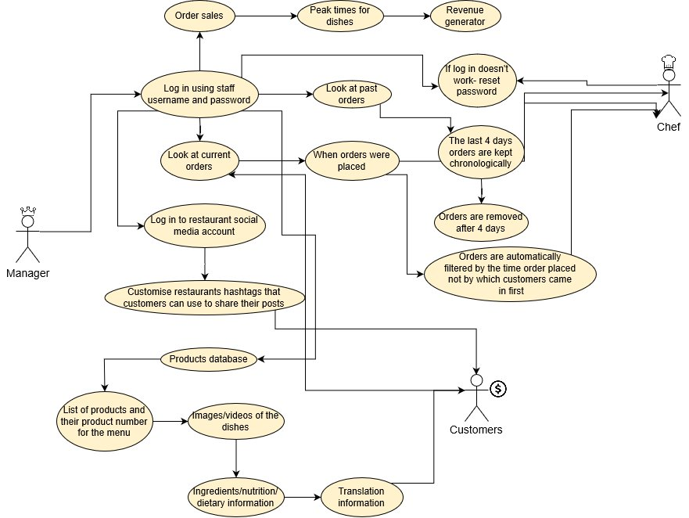

Figure 2: New Use Case diagram for admin/managers side

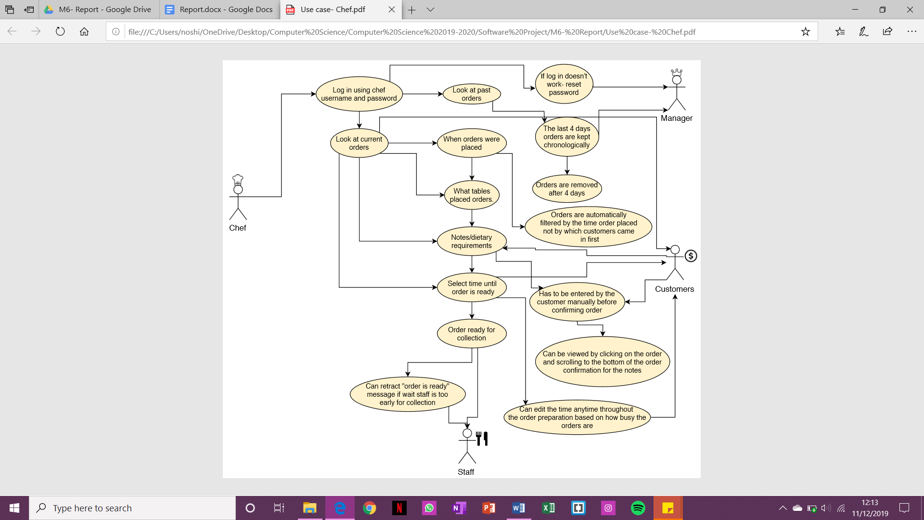

Figure 3: Use Case diagram for chef side

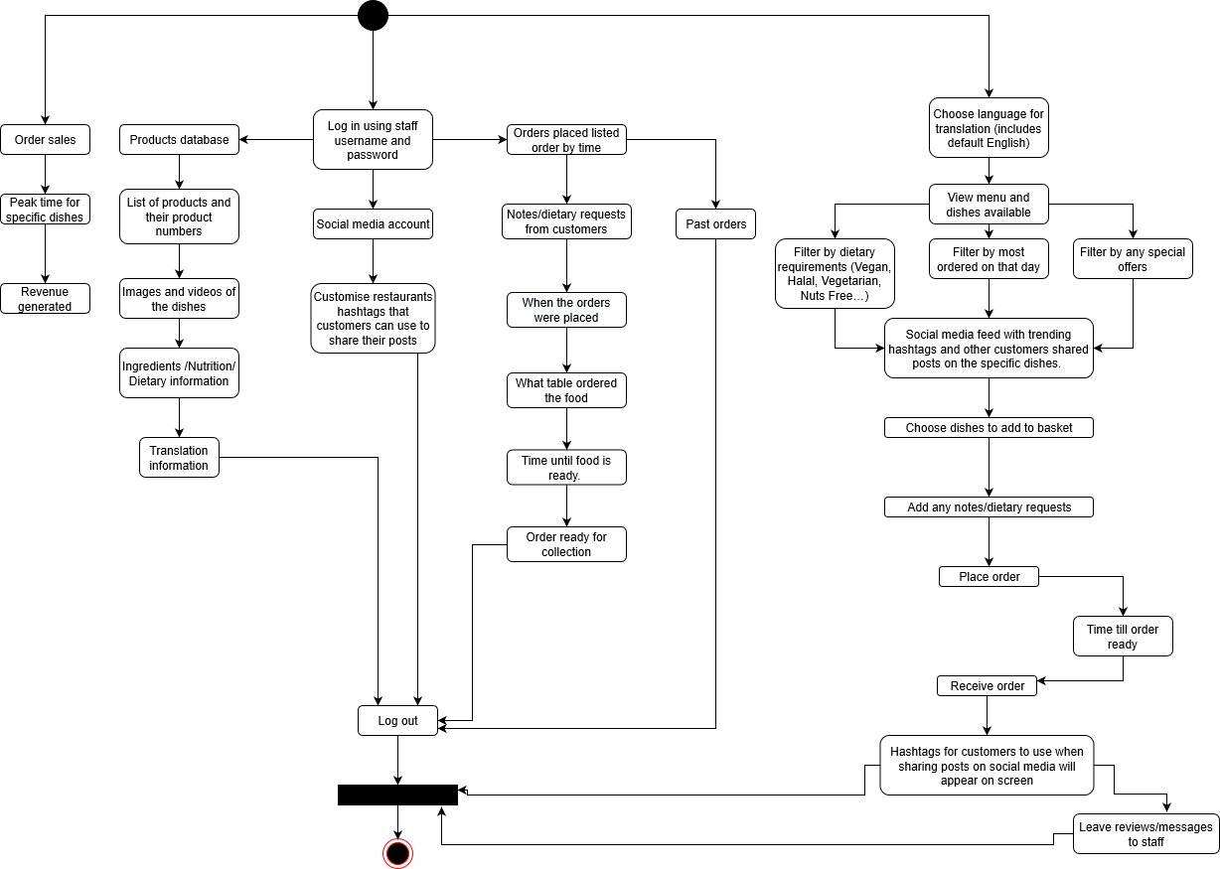

Figure 4 Activity Diagram with updates enabling login system, which was not present before

## UML Diagram updated

This section will consist of the changes applied to the first version of the Unified Model Diagram against the original version created during the M3 (Design) milestone creation period. 9

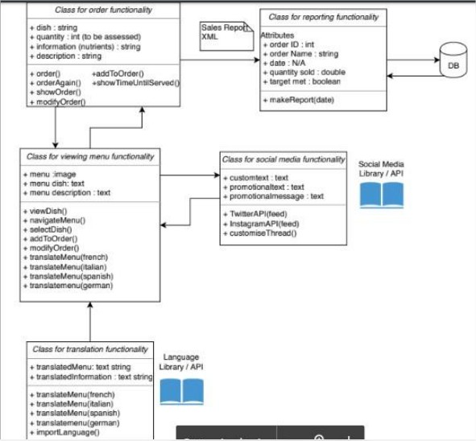

Figure 5 First UML of the project

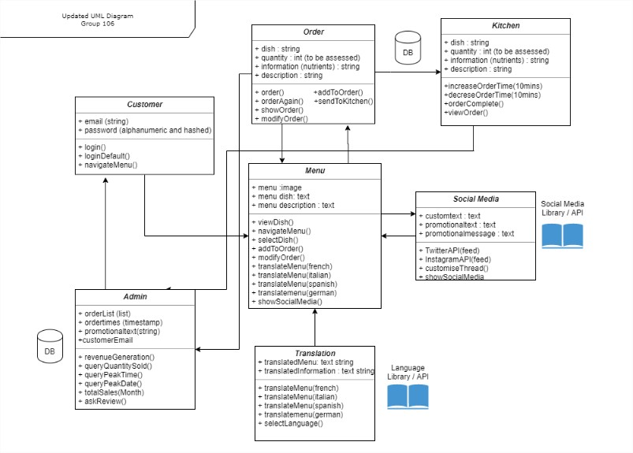

Figure 6 shows the new version of the UML with more clarified entities

## Use case diagram for customer

Figure 7 shows old customer use case

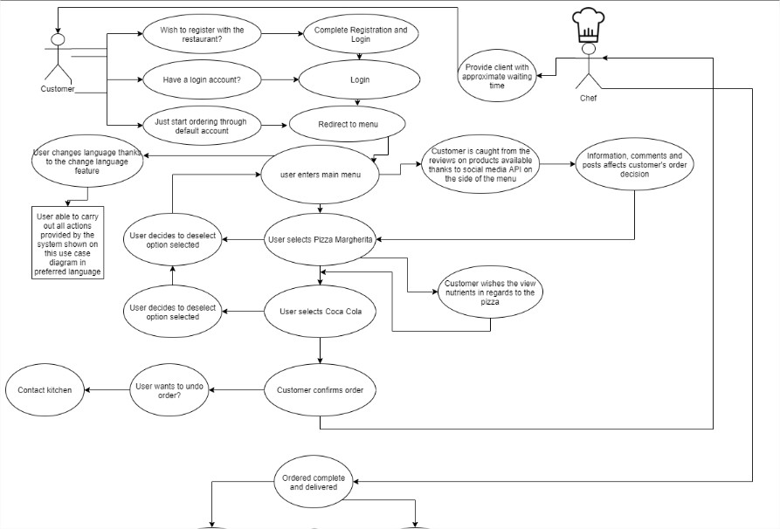

Figure 8 shows updated customer use case

## Sequence Diagrams

### Sequence diagram customer

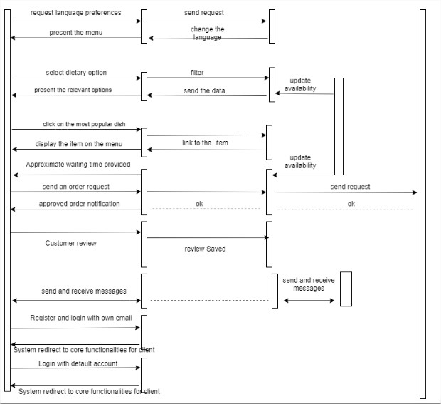

Figure 9 shows old customer sequencing diagram

Figure 10 is showing the updated customer sequence diagram

### Sequence diagram chef

Figure 11 is the original chef sequence diagram

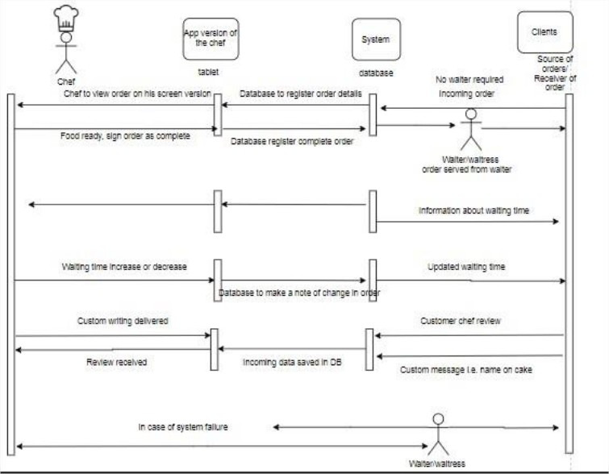

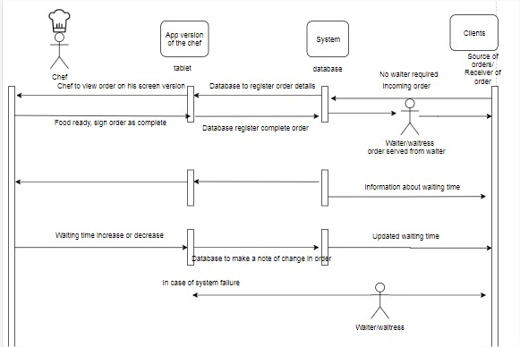

Figure 12 shows updated chef sequence diagram

### Sequence diagram admin

Figure 13 is the original admin sequence diagram

Figure 14 shows the updated admin sequence diagram with peak time queries

# Prototyping:

Low Fidelity prototyping contributed to a better idea of the wireframe. We explained our vision and showed them these sketches. (Sketches are shown in the appendices).

*Figure – Feedback from client 1*

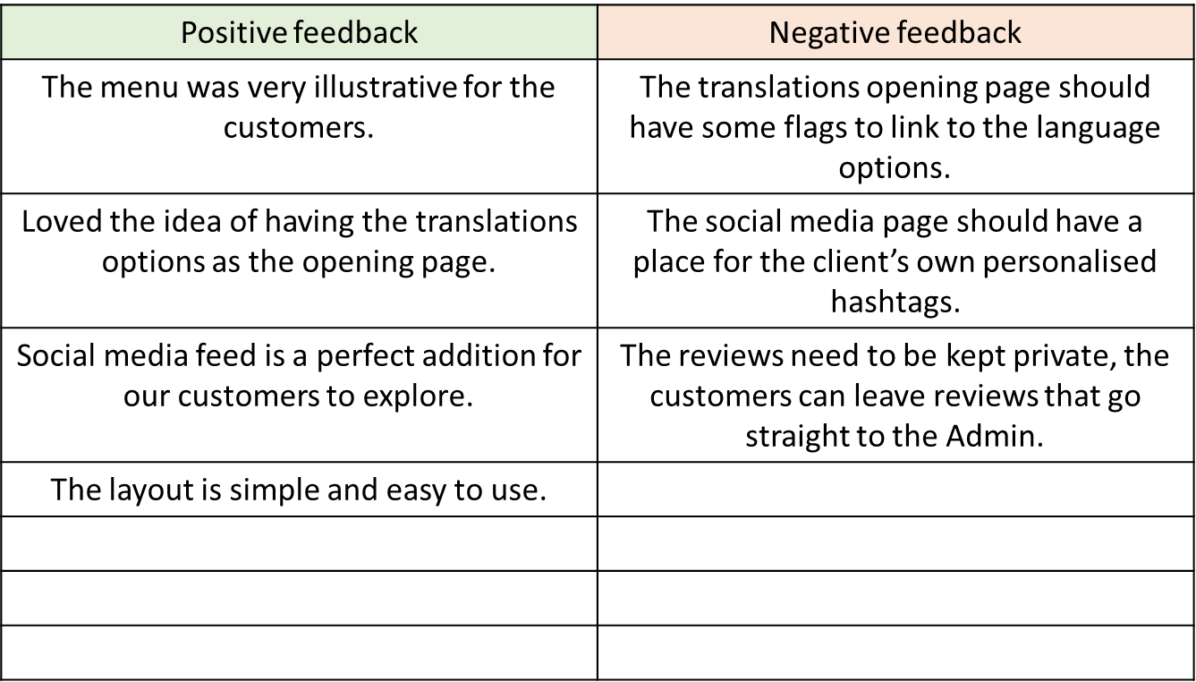

Figure 13 prototyping feedback

Changes are incorporated into High Fidelity

The functioning high fidelity prototype can be seen and tested on Marvel.10

This functioning prototype was shown to the client, she used and tested the prototype. The feedback was:

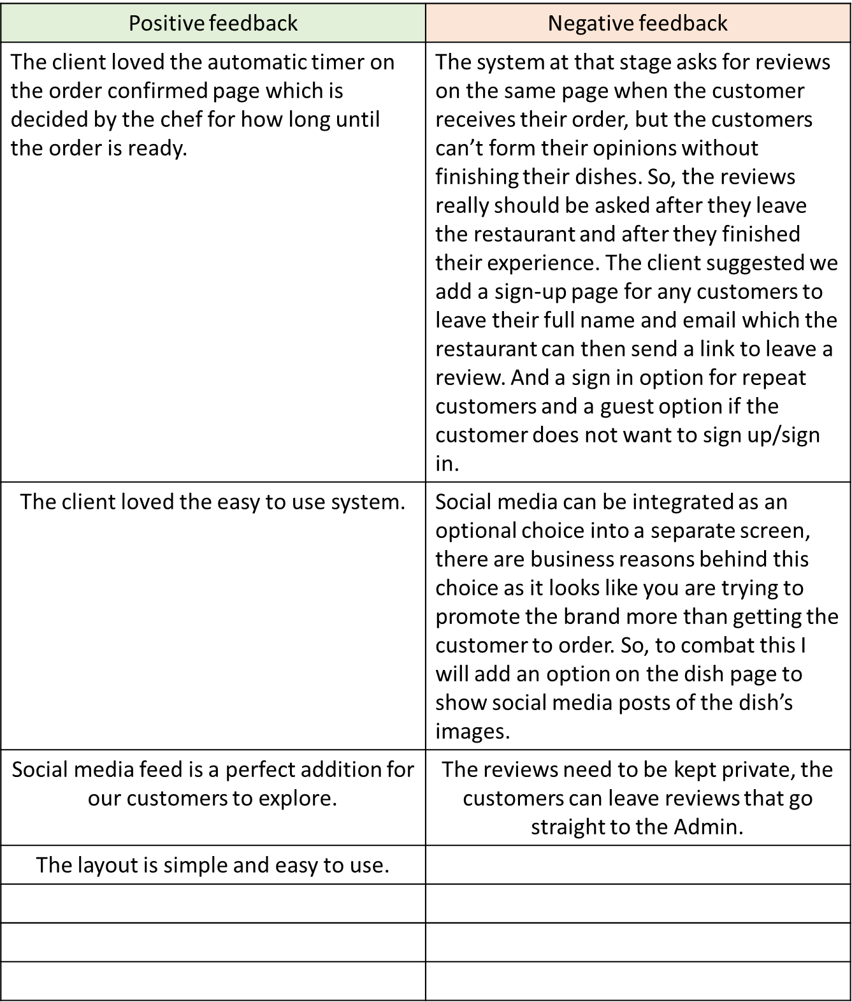

Figure 14 additional prototyping feedback

The high-fidelity prototype has been reviewed by international food bloggers who particularly emphasised on the translation functionality and expressed a positive view. 11

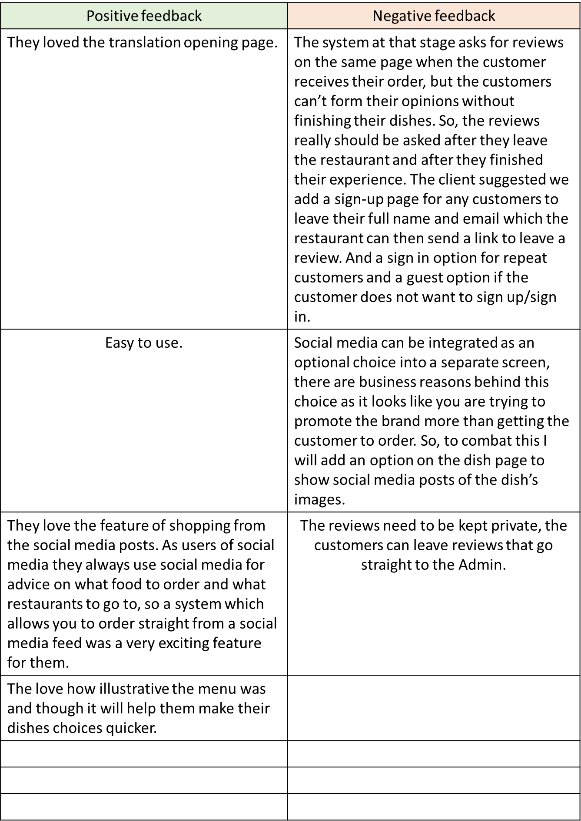

Figure 15 additional prototyping feedback

## High Fidelity Prototypes for Customer Side

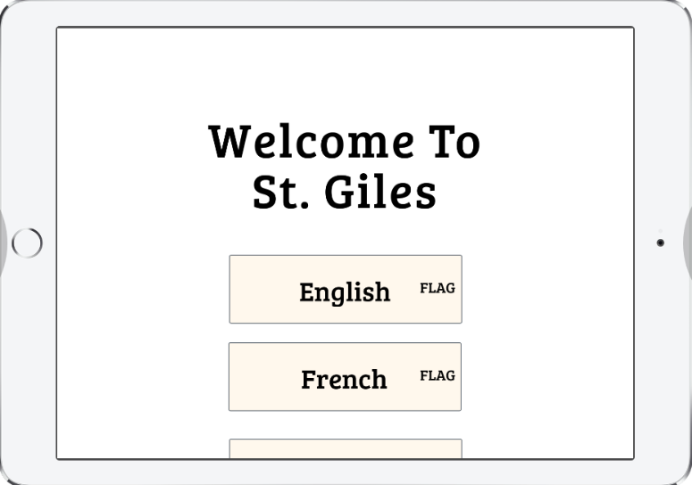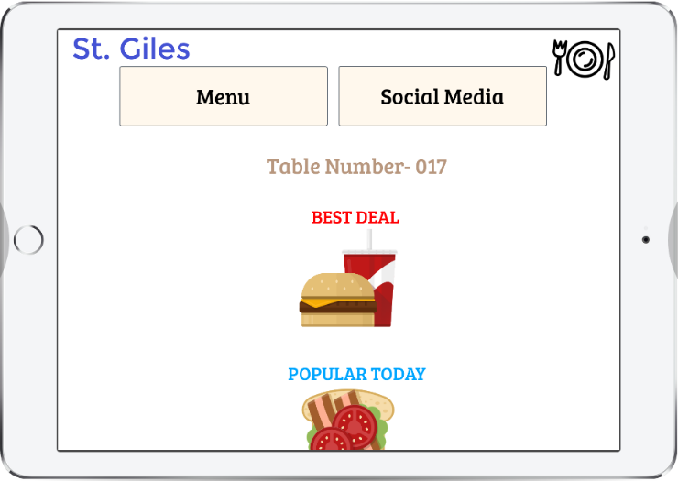

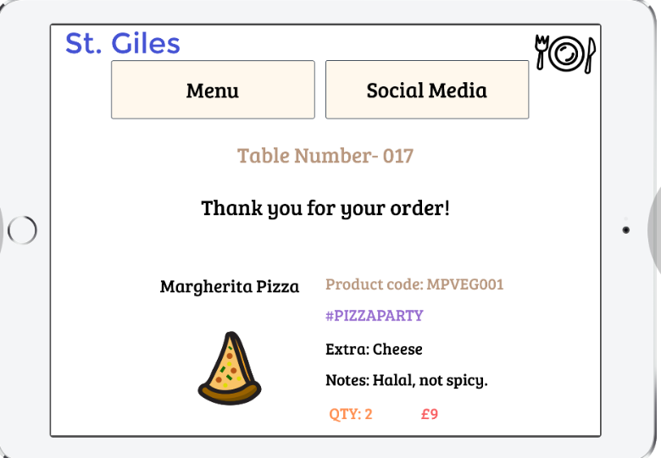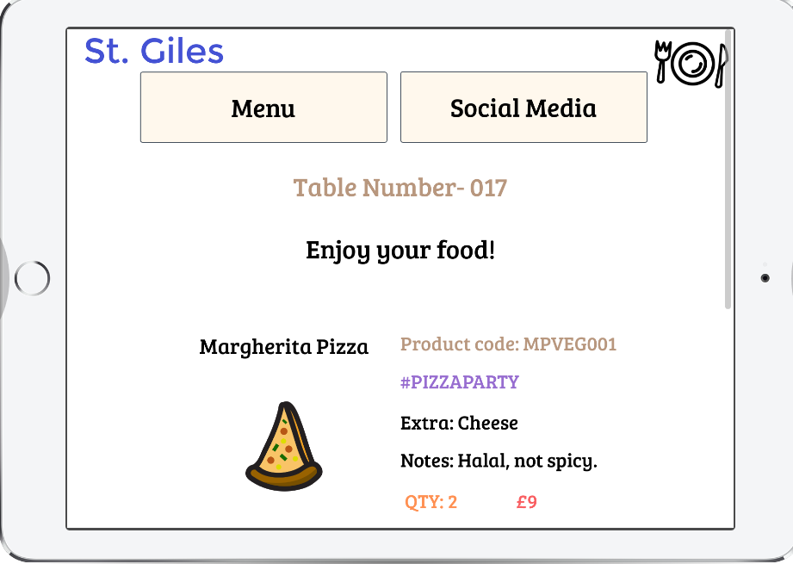

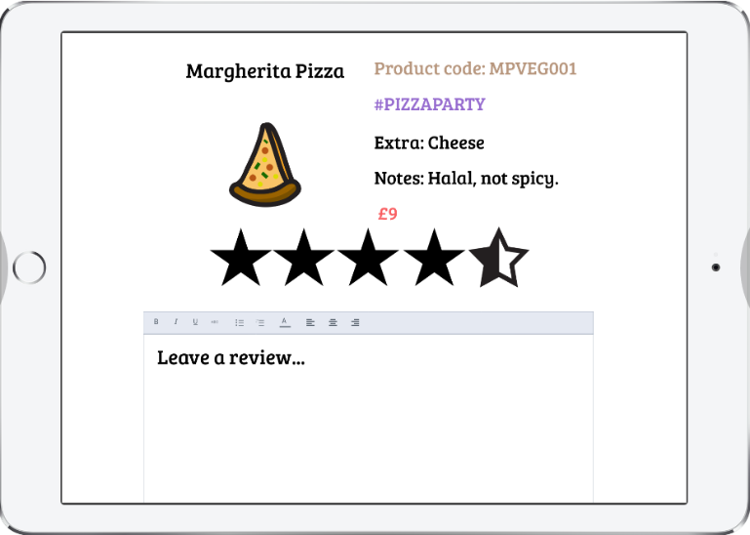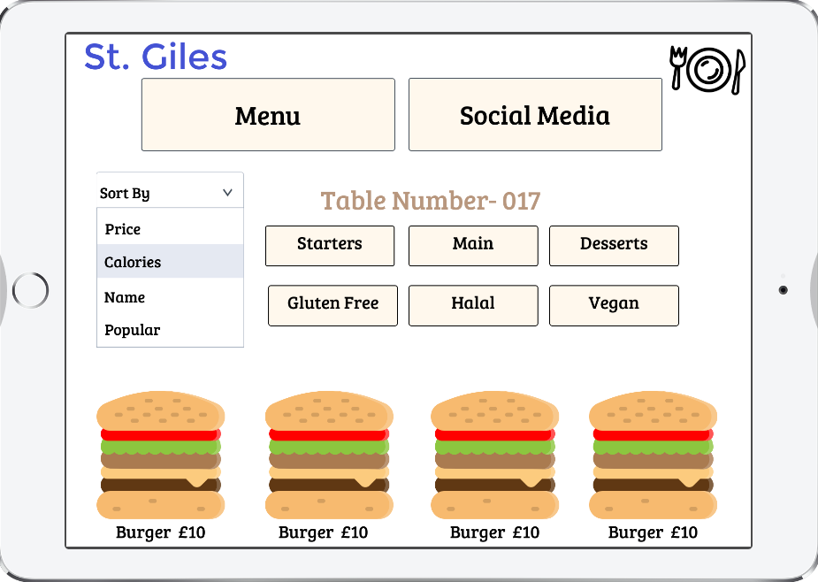

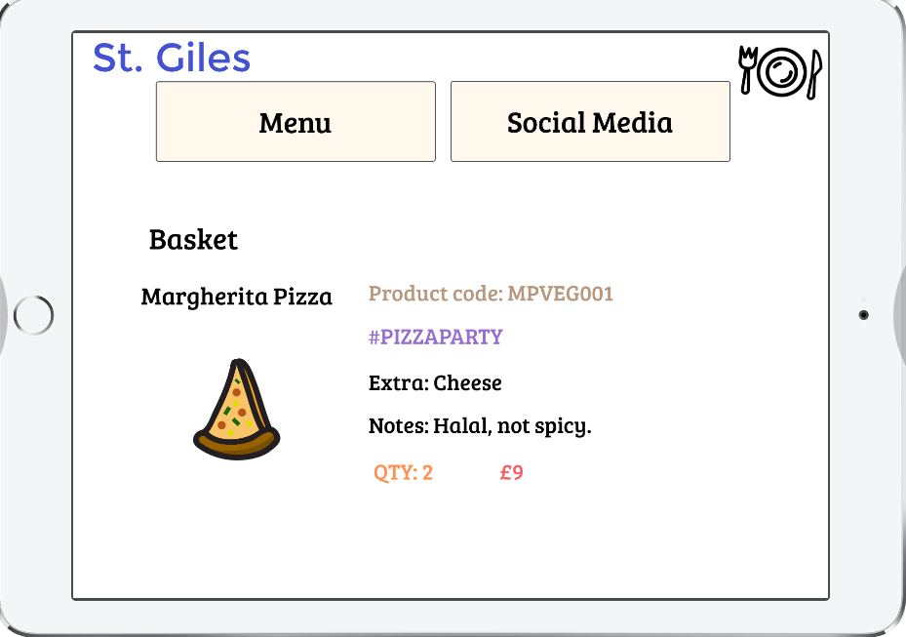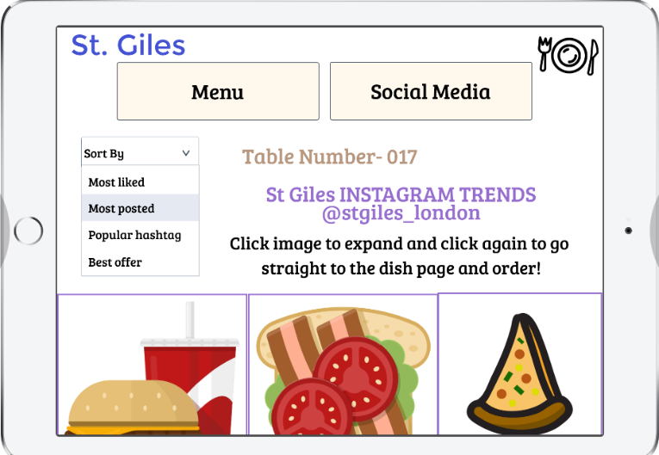

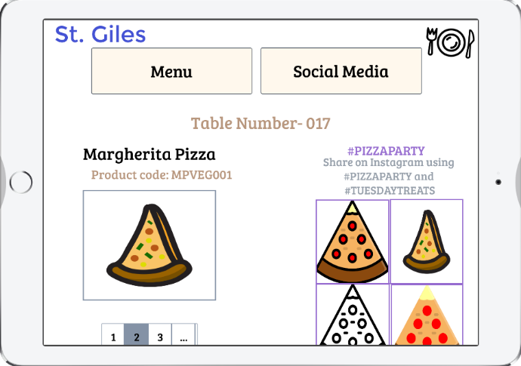

### Changes made as a result of client/stakeholder feedback

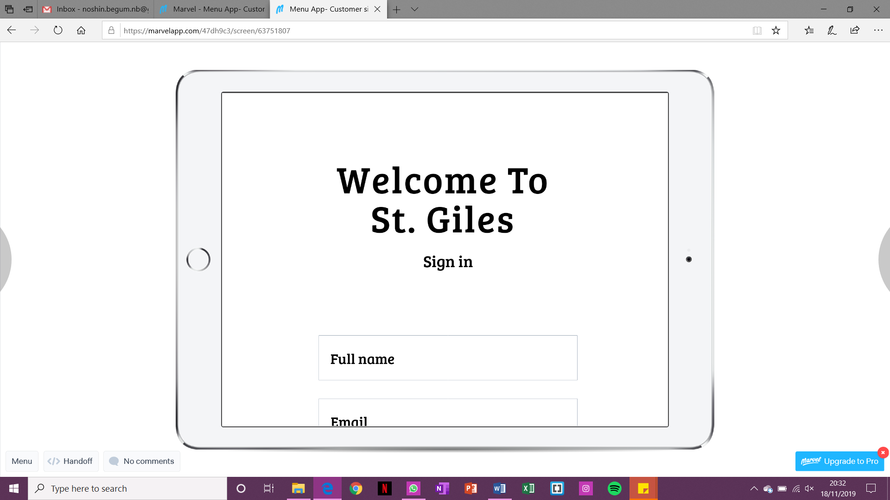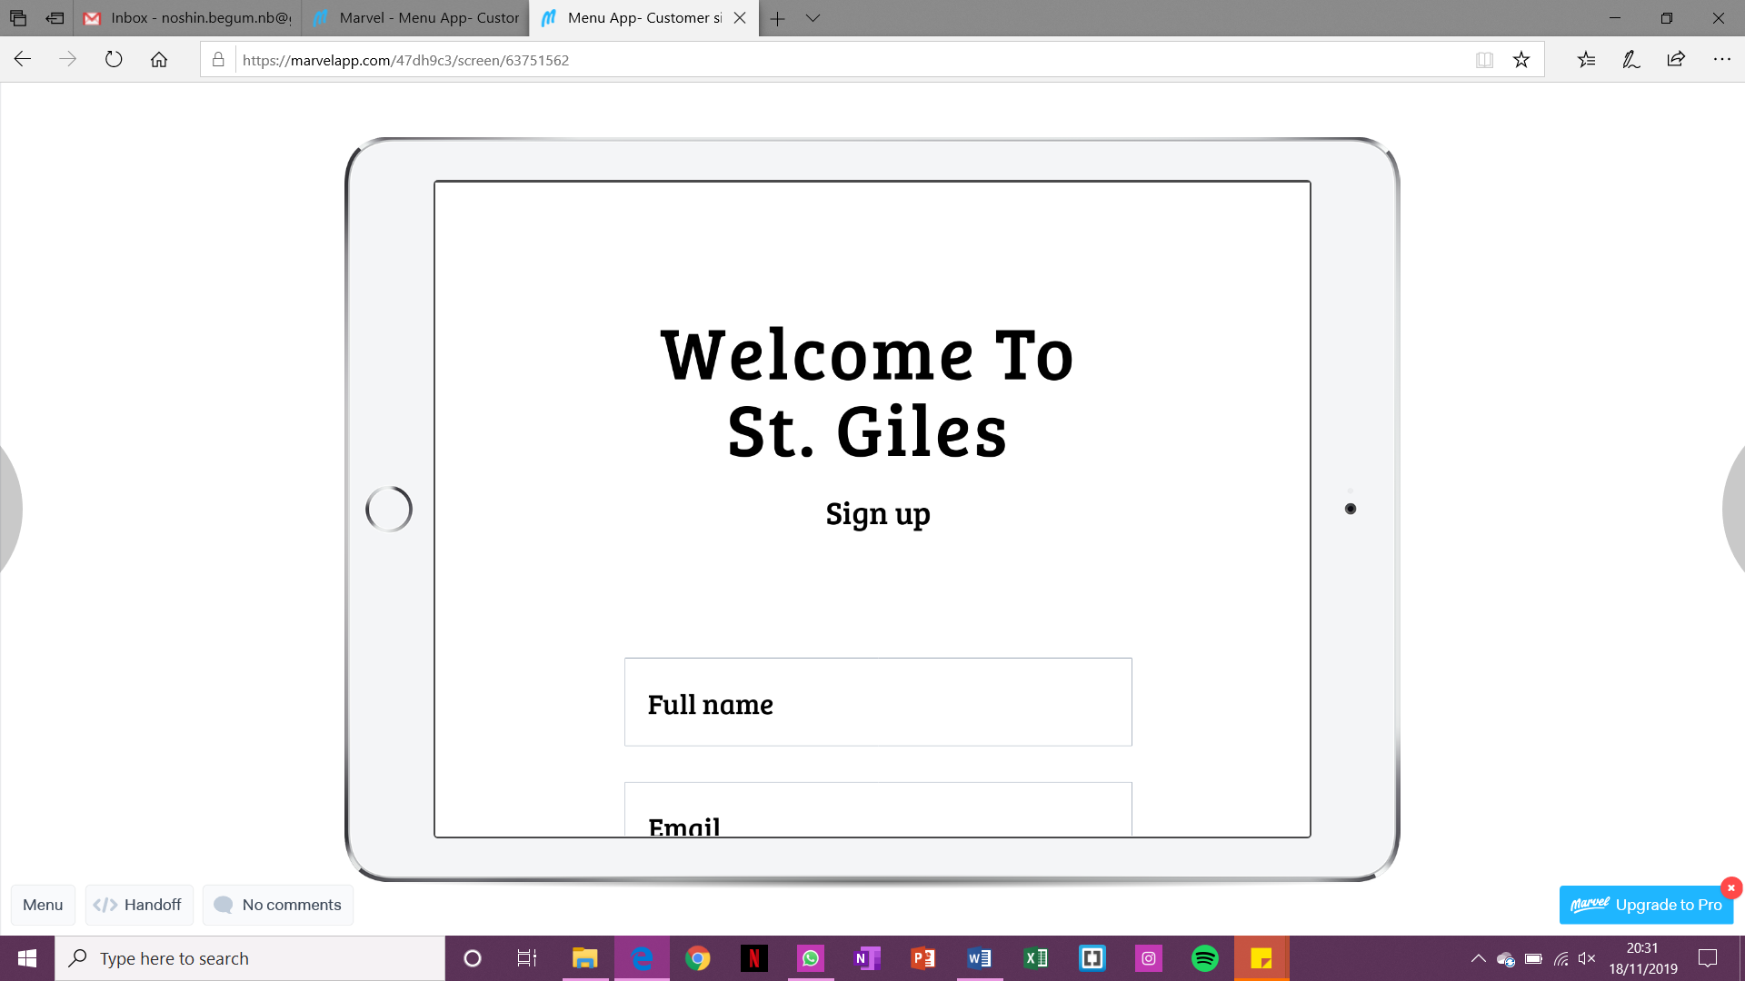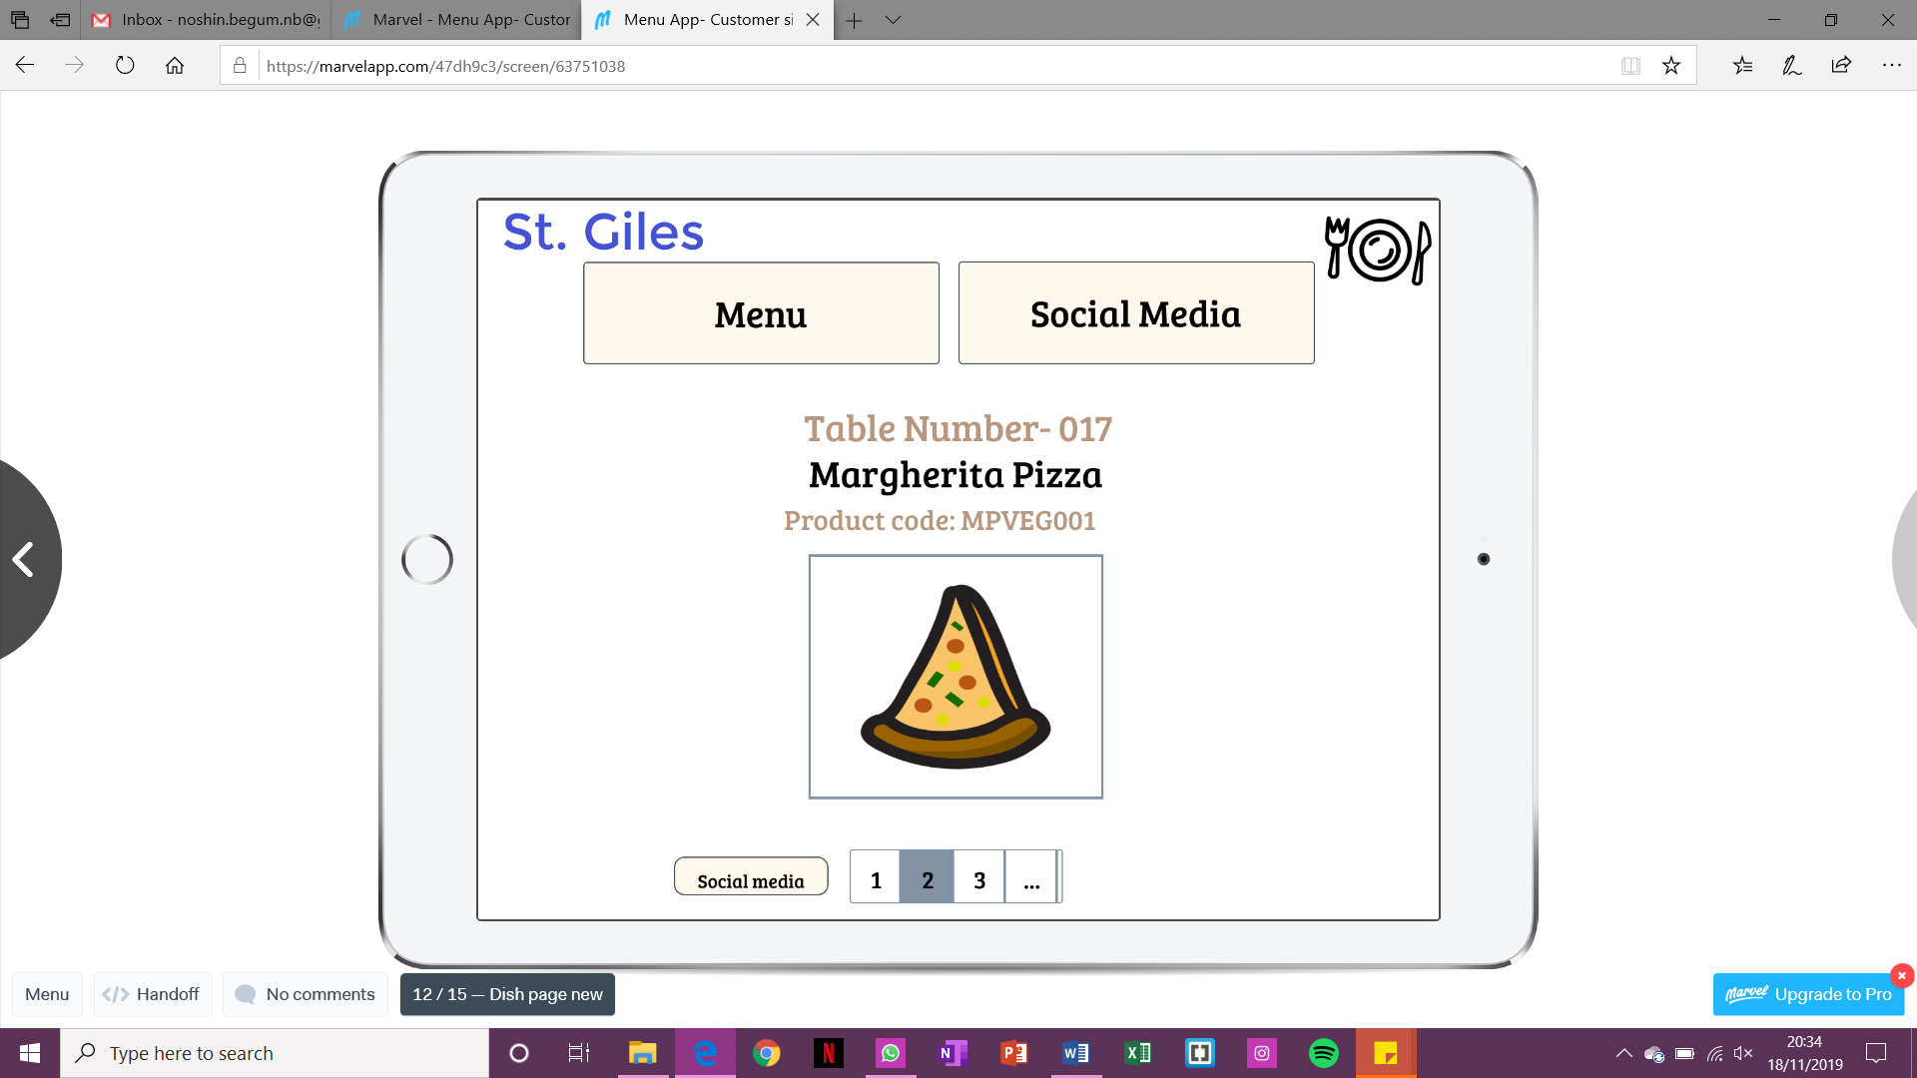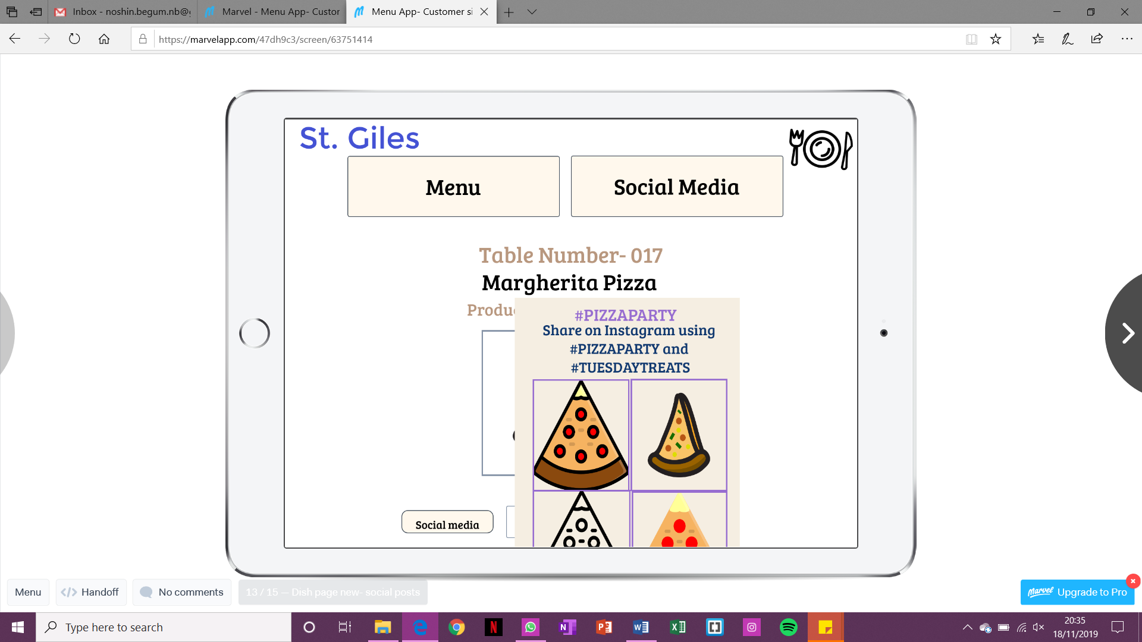

## High-Fidelity Prototype for Admin

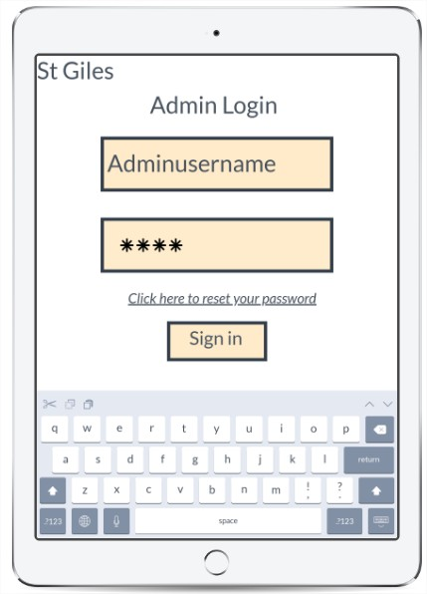

[1]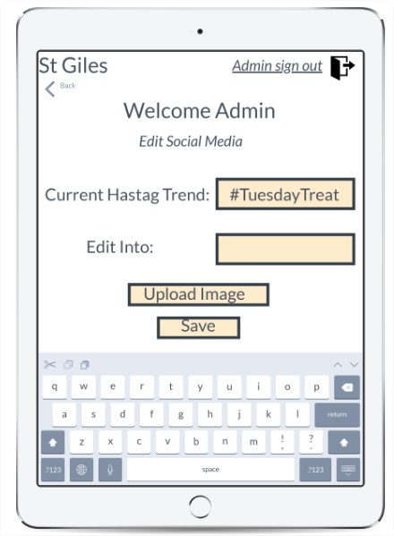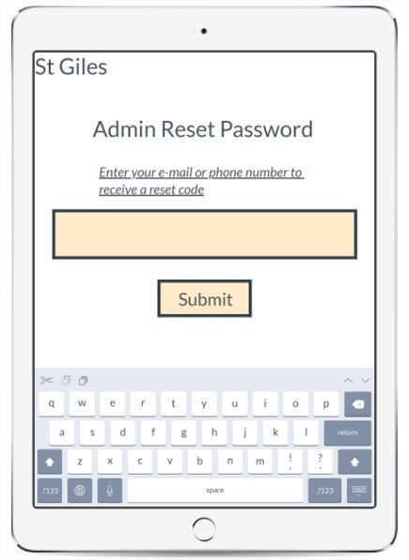

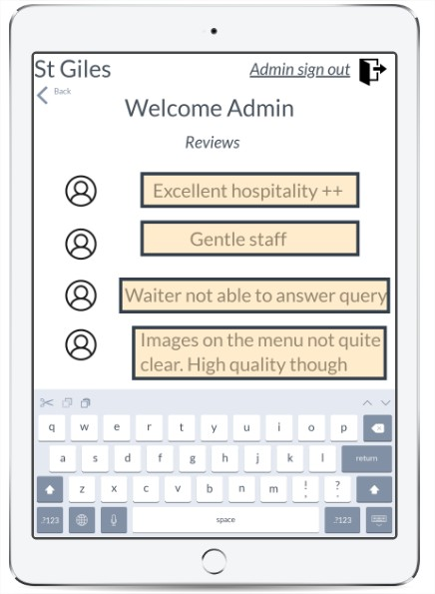

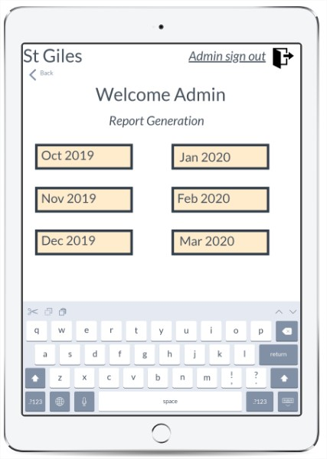

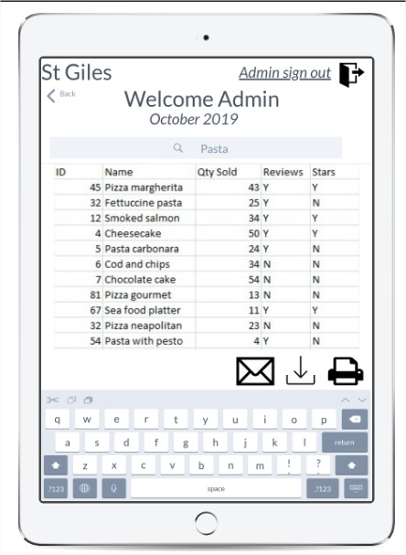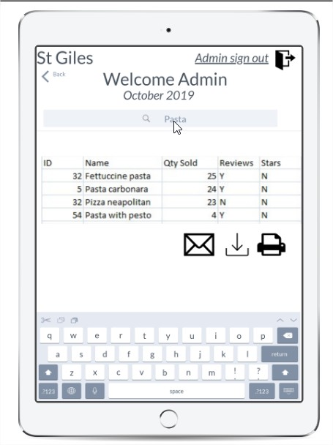

**Reflection and changes from admin point of view on the feedback**

* More features need to be added on the control panel of the admin
* Think more about the tables and the fields of information provided
* Monthly sales should have the quantity of reviews not a Y or a N

**Response to feedback**

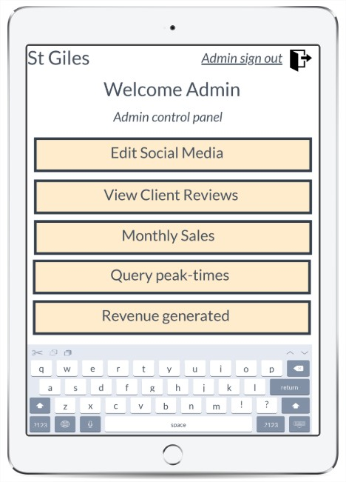[2]

Figure 16

Figure 18 shows the changes that have been made to the control panel of the admin side. The new features that have been added to add an extra layer of complexity in the prototype are Query peak times and revenue generated.12

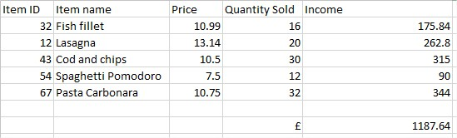**Possible tables for revenue generated**

The table above is representing potential data to represent the revenue generated. Suitable for MySQL implementation.

**Possible table for peak-time queries**

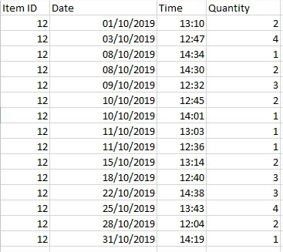

Figure 17

Figure 19 is a representation of the possible table structure that can be adopted for querying peak times. The redundancy aspect will be revisited in later phases

## High Fidelity for Chef Side

Figure 18 is showing the high-fidelity for kitchen side before the feedback changes were applied

### Changes applied for kitchen side:[3]

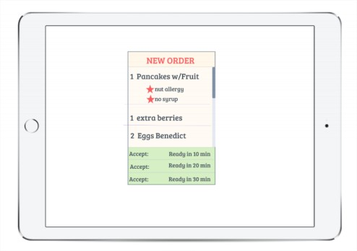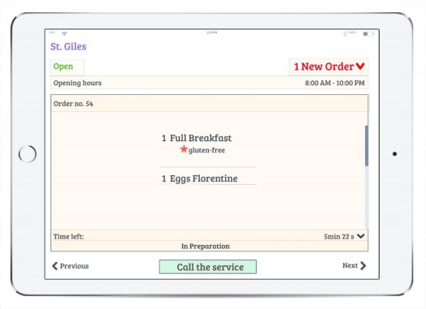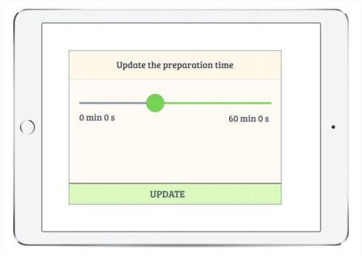

## Technical prototypes

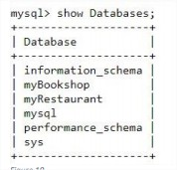

Figure 19 is showing the myRestaurant Database

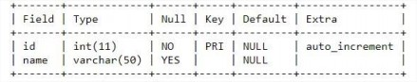

Figure 20 constructing fields

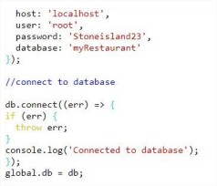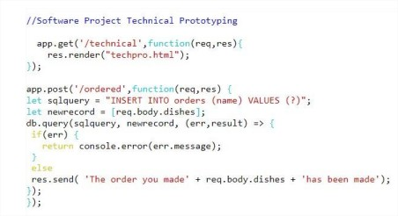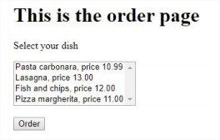

Figure 23 SQL code

Figure 24 shows DB connection

Figure 25 shows simple example of Order page that stores data in relational table

# Functional Specification:

The functional specification will be defined into a table format in the upcoming sections. They have been organised into the three main entities of this system: customer, kitchen and admin. The specification table in the next section does not mention any specific technologies, rather actions users are expected to accomplish.

# Technical Architecture:

Our team has decided to develop a web application (HTML, **CSS** & JavaScript) for the system over making a platform specific system such as **Android** or **IOS**. **API**’s can also be implemented.

Having to consider database and server-side technologies such as Node.JS, Express and MySQL for relational and structured databases.

Also, the underlying engines are designed to adapt to any operating systems including Android, IOS and even on the Windows Phone Operating System. 13 Hence **Android Studio** and IOS have been discarded.CSS can particularly work well with jQuery and JSON or **Globalize**.

In terms of **middleware** and server-side technology, we opted for Node JS along with Express. Node JS is a very easy to use door to the servers that we have been provided as part of this project.14Lastly some other technologies under consideration are Bootstrap, which a well-tested styling library which enables responsiveness.

# System Requirements & Technical Specification

## Purpose

# Scope

## Functional requirements

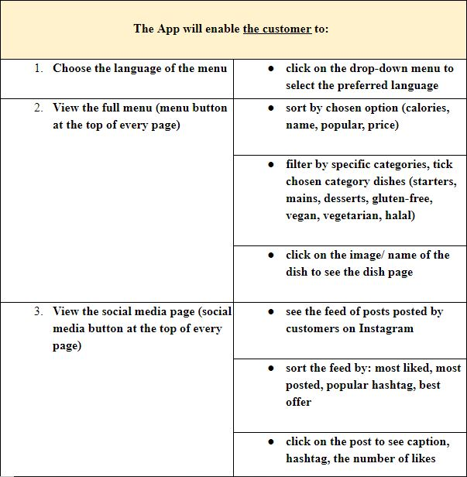

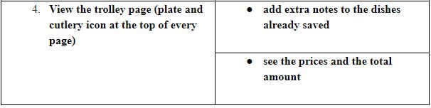

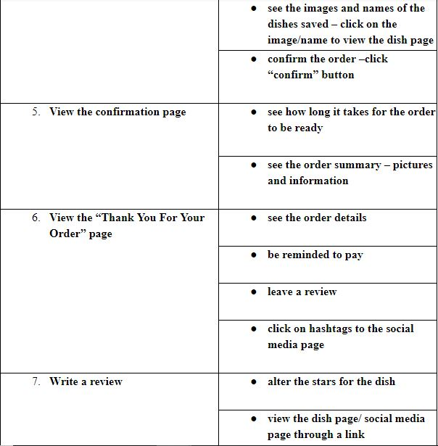

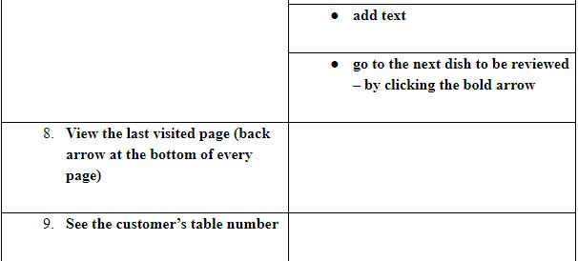

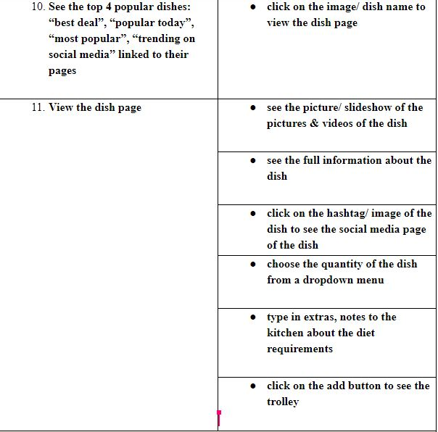

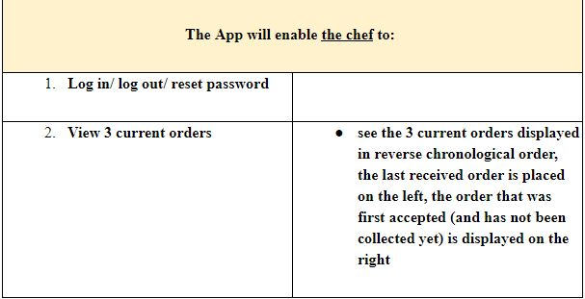

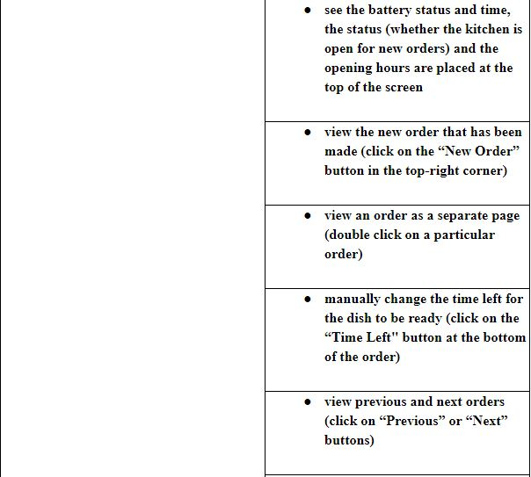

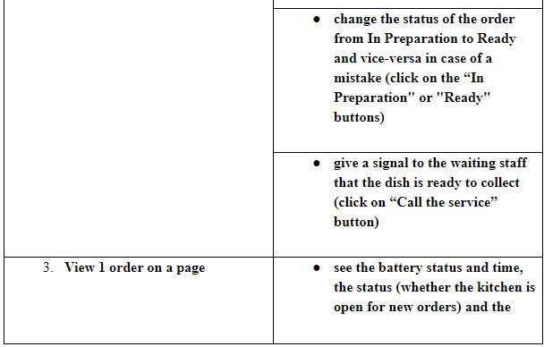

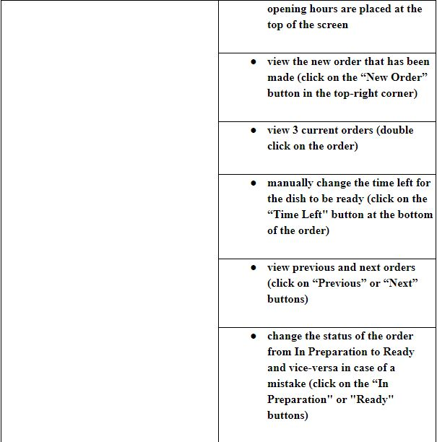

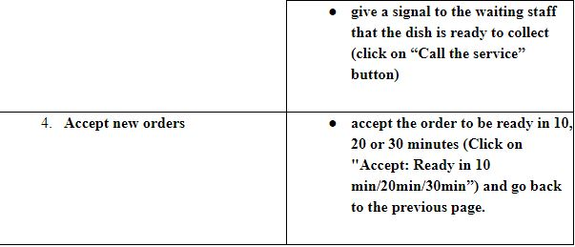

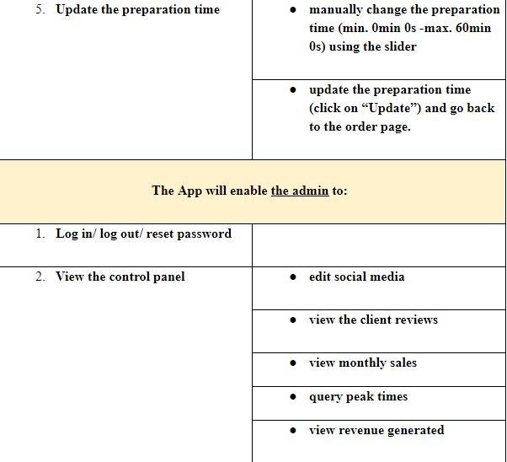

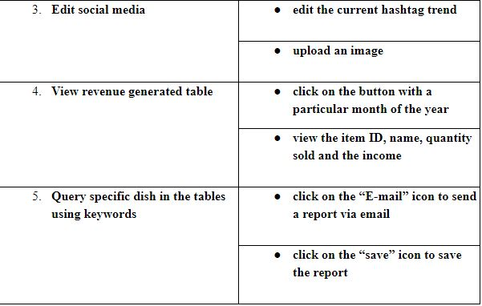

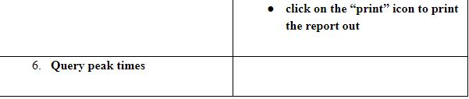

*Figure 26 Functional Requirements Table*

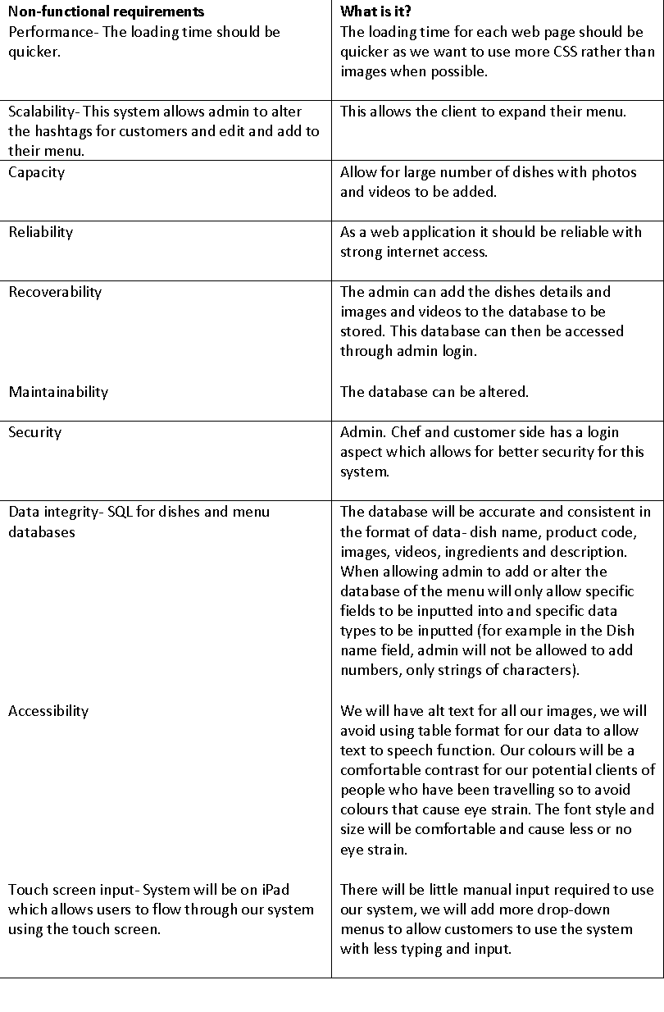**Non-Functional Requirements**

## System Overview & Technical Architecture

## The adoption of Model-View-Controller architecture as a strategy for web application to guarantee high usability is strongly suggested15

“The big idea behind MVC is that each section of your code has a purpose, and those purposes are different. Some of your code holds the data of your app, some of your code makes your app look nice, and some of your code controls how your app functions.”16

The MVC Architecture enables the separation of concerns that suits for this project, with appropriate separation of presentation, logic and backend layers fit for this purpose.

The **Repository Architecture** has been considered to fit the purpose, however the idea of having centralised data all in one place, and therefore the use of one database is not ideal for the Interactive Order System.

The data flow of our system needs to be relational and well-structured and needs to facilitate the reporting aspect.

We have also democratically rejected **Pipe and Filter** since our system will not be including a transactional or payment aspect.

Here is a tailored representation of how Model View Controller could fit our purpose.

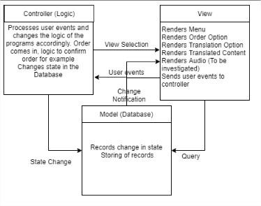

Figure 27 Model View Controller

## **References**

Voice over API – Text to speech API 17

jQuery – JavaScript library used for rendering animations and other dynamic functionalities including translation.18

Bootstrap – Widely used CSS framework for mobile responsiveness19

JSON – Example of semi-structured data for exchange of data between client-side and server-side20

Node JS – JavaScript Runtime Environment ideal for building dynamic web applications

Express – Express in the part of Node JS that manages the middleware software for server connection21

Globalize – JavaScript library for translation functionalities

## **Definitions**

**Android:** Android is a mobile operating system based on a modified version of the Linux kernel and other open source software.22

**Android Studio**: **Android Studio** is the official integrated development environment for Google's Android operating system,23

**API**: An application program interface (**API**) is a set of routines, protocols, and tools for building software applications. components.24

**CSS:** Cascading Style Sheets (CSS) is a stylesheet language used to describe the presentation of a document written in HTML.25

**IOS**: iOS is a mobile operating system created and developed by Apple Inc. exclusively for its hardware.26

**Middleware:** Middleware is computer software that provides services to software applications beyond those available from the operating system. It can be described as "software glue".27

**Minimum viable product:** A **minimum viable product** (MVP) is a version of a **product** with just enough features to satisfy early stages.28

**Pipe and Filter Architecture**: **Pipe and Filter** is another architectural pattern, which has independent entities called **filters** (components) which perform transformations. Filters.29

**Repository Architecture:** A **repository architecture** is a system that will allow several    interfacing components to share the same data component.30

**SQL:** **SQL** (pronounced "ess-que-el") stands for Structured Query Language. **SQL** is used to communicate with a database.31

**Virtual DOM:** The **virtual DOM** (VDOM) is a programming concept where an ideal, or “**virtual** “representation of a UI is kept in memory and synced with the “real” **DOM** by a library such as React DOM. This process is called reconciliation.32

**Ethical audit**

With our software project being a web application33, we believe we can avoid the use of data collection from the clients who use the application at the restaurants. This maximises problems for clients entering a restaurant and not feeling comfortable with sharing their details in a common setting like a restaurant, which you wouldn’t expect to share such information.

Data in our application is only on the admin side, which will include items on the menu. Log in details will be needed for this side of our application so privacy and security are highly needed. With our research into databases and we found that MySQL was our best option due to its easy maintained and tight security. Data being leaked could be very damaging to a restaurant and researching first into how to avoid any problems was our top priority.

We are not working individually with people with disabilities or children but being a restaurant application, which could still be used by anyone we needed to think through to minimise any problems. To minimise any problems to these groups of people we have made sure that our buttons for selecting on the iPad are of the appropriate size. Our biggest feature is our translation, we want all to be able to read the menu without difficulty. Restaurants attract tourism and the biggest problem we found is a lot of translation barriers between staff and clients. With bringing in this feature, the clients will not feel let down and frustrated and can order their meal without worrying about what they may or may not have ordered.

# Evaluation Plan

# Project management

Overall team performance has been positive. The team has allocated Bart Simpson to be Project Manager from M1 to M4, the current project manager is Winston Smith. The team uses regularly Trello for task management and GANTT charts for timescales, progress trackers also show correct timing breakdown. The upcoming sections will include project management evidence:

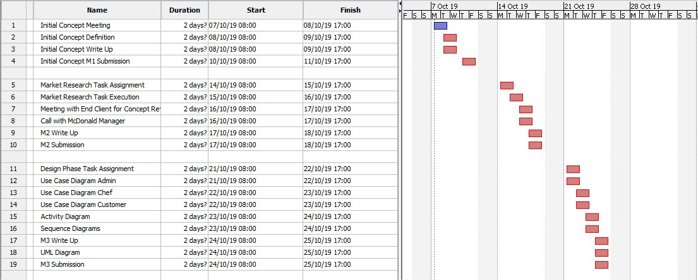

## Main GANTT Chart for larger task management (M1, M2, M3)

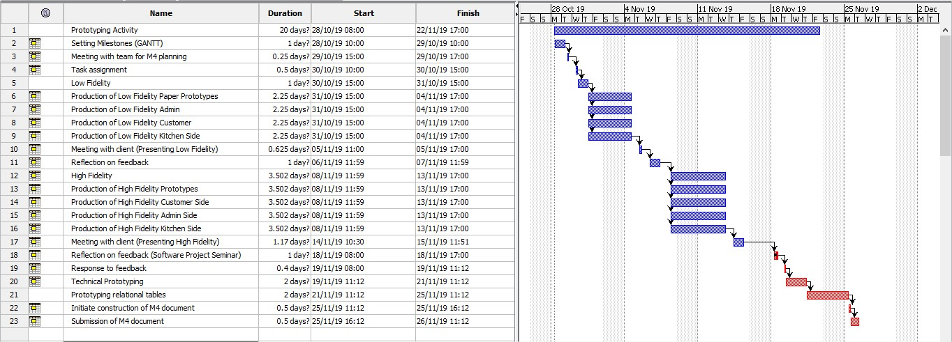

## Sub-GANTT subdivision of M4 milestones

## Trello for task management

## Development Methodology: Agile

Figure 28 Kanban Backlog

# Conclusion

As a conclusion, Team 6 has explored in depth the viability of the project, both under technical and commercial aspects. The design stage expanded our understanding of the interactions between different parts and the prototyping improved our visual understanding. The constant influence of our stakeholder keeps us into the Agile methodology as we are acting upon most feedback received. The system overview, functional and non-functional requirement is already guiding this project towards the development, those are fundamental elements to follow. We are looking forward to applying the technologies and the development methods mentioned in the best of our abilities for the next stages.

# Bibliography

1)Medium. (n.d.). *Perfect Menu for Mobile Apps*. [online] Available at:https://uxplanet.org/perfect-menu-for-mobile-apps-39b2cb5b7377 [Accessed 2 Oct. 2019].

2)Maria, A. (n.d.). *Go Global! The 6 Best Translation Apps for Language Learners*. [online] FluentU Language Learning. Available at:https://www.fluentu.com/blog/best-translation-apps/ [Accessed 2 Oct. 2019].

3) Wimpsett, E. (2019). *14 Must-Have Apps for Restaurant Owners | QSR Automations*. [online] QSR Automations. Available at: https://www.qsrautomations.com/blog/restaurant-management/apps-for-restaurant-owners/ [Accessed 12 Dec. 2019].

3) ShopKeep. (2019). *10 Restaurant Management Apps We Love and You Will Too*. [online] Available at: https://www.shopkeep.com/blog/10-restaurant-management-apps-we-love-and-you-will-too [Accessed 12 Dec. 2019].

3) Pos.toasttab.com. (2019). *35 Restaurant Management Tools and Apps to Help Supercharge Productivity | Toast POS*. [online] Available at: https://pos.toasttab.com/blog/productivity-apps-for-restaurants [Accessed 12 Dec. 2019].

3) Team, Z. (2019). *18 Apps that Restaurant Owners and Managers Must Have*. [online] Zonkafeedback.com. Available at: https://www.zonkafeedback.com/blog/top-18-apps-for-restaurant-owners [Accessed 12 Dec. 2019].

3) Kapitus. (2019). *must-have-apps-for-restaurant-owners*. [online] Available at: https://kapitus.com/blog/must-have-restaurant-tools-and-apps/ [Accessed 12 Dec. 2019].

3) Hubworks.com. (2019). [online] Available at: https://hubworks.com/blog/top-apps-for-restaurant-owners-business-management-apps-you-need.html [Accessed 12 Dec. 2019].

3) Blog.wagepoint.com. (2019). *100 Amazing Restaurant Software Apps You Need To Know*. [online] Available at: https://blog.wagepoint.com/all-content/100-amazing-restaurant-software-apps-you-need-to-know [Accessed 12 Dec. 2019].

3) Restaurant & Retail POS Software - Restaurant Management Software | Blog. (2019). *Restaurant Management Apps That Will Help Your Venture Cook Up Profits*. [online] Available at: https://www.rancelab.com/blog/restaurant-management-apps/ [Accessed 12 Dec. 2019].

3) TouchBistro. (2019). *8 Apps Every Restaurateur Can’t Live Without*. [online] Available at: https://www.touchbistro.com/blog/8-apps-every-restaurateur-can-t-live-without/ [Accessed 12 Dec. 2019].

3) Roque, C. (2018). *7 Reasons Why Marketing Research Is Important to a Business*. [online] Business Envato Tuts+. Available at:https://business.tutsplus.com/articles/why-is-marketing-research-important--cms-31593 [Accessed 24 Sep. 2019].

3) Start Up Loans Company. (n.d.). *Examples of market research | Start Up Loans*. [online] Available at:<https://www.startuploans.co.uk/business-advice/examples-of-market-research/> [Accessed 22 Sep. 2019].

3) SurveyGizmo. (n.d.). *Types of Market Research and Their Differences*. [online] Available at:<https://www.surveygizmo.com/resources/blog/market-research-types/> [Accessed 22 Sep. 2019].

4) Ordamo. (2019). *Ordamo | Digital Menus for Your Guests*. [online] Available at: https://www.ordamo.com/?utm_source=adwords-remarketing-search&gclid=Cj0KCQjwoqDtBRD-ARIsAL4pviC6nhn-GzTzeOYOL-RRPwts8DfNZbGAMt3_Gmc6PuCUV_1ldTGDEtgaArqwEALw_wcB [Accessed 12 Dec. 2019].

5) Ambur Marketing. (2019). *Restaurant POS Features | iPad POS System | Ambur POS*. [online] Available at: http://www.amburapp.com/features [Accessed 12 Dec. 2019].

6) Pour My Beer. (2019). *System - Pour My Beer*. [online] Available at: https://pourmybeer.com/system/ [Accessed 12 Dec. 2019].

7) This is Ziosk. (2019). *This is Ziosk.*. [online] Available at: https://www.ziosk.com/#zpay [Accessed 12 Dec. 2019].

8) Ordamo. (2019). *Ordamo | Digital Menus for Your Guests*. [online] Available at: https://www.ordamo.com/?utm_source=adwords-remarketing-search&gclid=Cj0KCQjwoqDtBRD-ARIsAL4pviC6nhn-GzTzeOYOL-RRPwts8DfNZbGAMt3_Gmc6PuCUV_1ldTGDEtgaArqwEALw_wcB [Accessed 12 Dec. 2019].

9) Visual-paradigm.com. (n.d.). *What is Use Case Diagram?* [online] Available at:<https://www.visual-paradigm.com/guide/uml-unified-modeling-language/what-is-use-case-diagram/> [Accessed 2 Oct. 2019].

9) GeeksforGeeks. (n.d.). *Unified Modelling Language (UML) | Sequence Diagrams - GeeksforGeeks*. [online] Available at:<https://www.geeksforgeeks.org/unified-modeling-language-uml-sequence-diagrams/> [Accessed 2 Oct. 2019].

9)Visual-paradigm.com. (n.d.). *What is Sequence Diagram?* [online] Available at:<https://www.visual-paradigm.com/guide/uml-unified-modeling-language/what-is-sequence-diagram/> [Accessed 2 Oct. 2019].

10) Marvel - The design platform for digital products [online] available at: [https://marvelapp.com](https://marvelapp.com/) [accessed 10 Oct. 2019]

11) Espioto, E. (2018). *Low-fidelity vs. high-fidelity prototyping*. [online] Invisionapp.com. Available at:<https://www.invisionapp.com/inside-design/low-fi-vs-hi-fi-prototyping/> [Accessed 9 Nov. 2019].

11) Liu, T. (2017). *High-Fidelity & Low-Fidelity Prototyping: What, When and How?*. [online] Medium. Available at:<https://medium.com/@tristaljing/high-fidelity-low-fidelity-prototyping-what-when-and-how-4f2a7037be1f> [Accessed 20 Nov. 2019].

11) Medium. (2018). *How to pick colors for your app without a struggle*. [online] Available at:<https://uxdesign.cc/how-to-pick-colors-for-your-app-without-a-struggle-bc46c5e19574> [Accessed 13 Nov. 2019].

12) Eriksson, U. (2012). *Functional Requirements vs Non Functional Requirements*. [online] ReQtest. Available at:<https://reqtest.com/requirements-blog/functional-vs-non-functional-requirements/> [Accessed 29 Nov. 2019].

12)Website Guides, Tips and Knowledge. (2014). *10 Ways to Make Your Website Accessible - DreamHost*. [online] Available at:<https://www.dreamhost.com/blog/make-your-website-accessible/> [Accessed 1 Dec. 2019].

12) Morton, R. (2016). *Colour contrast - why does it matter? - Accessibility in government*. [online] Accessibility.blog.gov.uk. Available at:<https://accessibility.blog.gov.uk/2016/06/17/colour-contrast-why-does-it-matter/> [Accessed 1 Dec. 2019].

13) En.yeeply.com. (2019). *Web App Development: Advantages and Disadvantages*. [online] Available at: <https://en.yeeply.com/blog/advantages-and-disadvantages-of-web-app-developmen>t/ [Accessed 6 Dec. 2019].

14) Dickey, Jeff. Write Modern Web Apps with the MEAN Stack: Mongo, Express, AngularJS, and Node.js. 2015. Print. Develop and Design.

15) Hasan, S.S, and R.K Isaac. "An Integrated Approach of MAS-Common KADS, Model–View–Controller and Web Application Optimization Strategies for Web-based Expert System Development." Expert Systems with Applications 38.1 (2011): 417-28. Web.

16) *MVC: Model, view, controller.* Available at: <https://www.codecademy.com/articles/mvc> (Accessed: 02 December 2019).

17) ResponsiveVoice.JS Text to Speech. (2019). *Responsive Voice Text To Speech - ResponsiveVoice.JS Text to Speech*. [online] Available at: https://responsivevoice.org/ [Accessed 6 Dec. 2019].

18) js.foundation, J. (2019). *jQuery UI*. [online] Jqueryui.com. Available at: https://jqueryui.com/ [Accessed 6 Dec. 2019].

19) W3schools.com. (2019). *What is Bootstrap*. [online] Available at: https://www.w3schools.com/whatis/whatis_bootstrap.asp [Accessed 6 Dec. 2019].

20) Ronk, J. (2019). *Structured, semi structured and unstructured data*. [online] Jeremy Ronk. Available at: https://jeremyronk.wordpress.com/2014/09/01/structured-semi-structured-and-unstructured-data/ [Accessed 6 Dec. 2019].

21) Expressjs.com. (2019). *Express - Framework per applicazioni web Node.js*. [online] Available at: https://expressjs.com/it/ [Accessed 6 Dec. 2019].

22) En.wikipedia.org. (2019). *Android (operating system)*. [online] Available at: <https://en.wikipedia.org/wiki/Android_(operating_system)> [Accessed 6 Dec. 2019].

23) En.wikipedia.org. (2019). *Android Studio*. [online] Available at: <https://en.wikipedia.org/wiki/Android_Studio> [Accessed 6 Dec. 2019].

24) Webopedia.com. (2019). *What is API - Application Program Interface? Webopedia Definition*. [online] Available at: <https://www.webopedia.com/TERM/A/API.html>[Accessed 6 Dec. 2019].

25) MDN Web Docs. (2019). *CSS: Cascading Style Sheets*. [online] Available at: <https://developer.mozilla.org/en-US/docs/Web/CSS>[Accessed 6 Dec. 2019].

26) En.wikipedia.org. (2019). *IOS*. [online] Available at: <https://en.wikipedia.org/wiki/IOS>[Accessed 6 Dec. 2019].

27) En.wikipedia.org. (2019). *Middleware*. [online] Available at: <https://en.wikipedia.org/wiki/Middlewar>e [Accessed 6 Dec. 2019].

28) En.wikipedia.org. (2019). *Minimum viable product*. [online] Available at: <https://en.wikipedia.org/wiki/Minimum_viable_product> [Accessed 6 Dec. 2019].

29) Medium. (2019). *Pipe and Filter Architecture*. [online] Available at: <https://medium.com/@syedhasan010/pipe-and-filter-architecture-bd7babdb908> [Accessed 6 Dec. 2019].

30) architecture, r., boyajian, m., ଦାଶ), T. and Casimiro, J. (2019). *repository and client-server architecture - CodeProject*. [online] Codeproject.com. Available at: <https://www.codeproject.com/Questions/682701/repository-and-client-server-architecture> [Accessed 6 Dec. 2019].

31) Sqlcourse.com. (2019). *SQLCourse - Lesson 1: What is SQL?*. [online] Available at: <http://www.sqlcourse.com/intro.html>[Accessed 6 Dec. 2019].

32) Reactjs.org. (2019). *Virtual DOM and Internals – React*. [online] Available at: <https://reactjs.org/docs/faq-internals.html> [Accessed 6 Dec. 2019].

33) Spotify.design. (2019). *Designing for Tomorrow - A Discussion on Ethical Design*. [online] Available at: https://spotify.design/articles/2019-01-18/designing-for-tomorrow-a-discussion-on-ethical-design/ [Accessed 12 Dec. 2019].

33) Webaccess.berkeley.edu. (2019). *Top 10 Tips for Making Your Website Accessible | Web Access*. [online] Available at: https://webaccess.berkeley.edu/resources/tips/web-accessibility [Accessed 12 Dec. 2019].

33) Work Life by Atlassian. (2019). *The new rules of ethical design in tech - Work Life by Atlassian*. [online] Available at: https://www.atlassian.com/blog/technology/ethical-design-in-tech [Accessed 12 Dec. 2019].

33) Bcs.org. (2019). [online] Available at: https://www.bcs.org/membership/become-a-member/bcs-code-of-conduct/ [Accessed 12 Dec. 2019].

# Appendices

## Concept Meeting with SugarOverdose Narnia Hotel Attendees:

Bart Simpson

Frankenstein (Manager at SugarOverdose Narnia)

Date: 17/10/2019

Start time: 11:00

End time: 11:34

Points covered:

* Client has a payment counter which includes a high-end card reader and a physical cash desk that has been in place for a long period of time, for the entirety of this time, the current transaction method at the till has been successful, the admin manager does not wish to replace such system.
* Given the fact that the location of the selected client for this project is near the Heathrow, London area – host of one of the largest airports in the world, the clientele varies from nationality to nationality.
* The admin manager confirmed that various cabin crews work in partnership with their business for hospitality. Predominant cabin crews include Air France KML, Lufthansa German Airline, Iberia airline (Spain), Alitalia (Italy) and of course British Airways.
* The admin manager has confirmed that in various occasions waiters and waitresses, in all meal sessions including breakfast, lunch and dinner must frequently consult the kitchen about queries that they have about meals (Ingredients etc.)
* The manager can foresee some potential improvement in the efficiency for the kitchen with a new order system in place. She likes the idea to help the chefs in the task of reading the orders but has shown some hesitations about some financial implications.
* In rare occasions, when the restaurant is completely full, it has happened that some client showed - interest in another table’s orders. This point was debated with the admin manager, she said that in occasions in which the restaurant is full, the clients usually book the space as a large group i.e. for wedding or celebrations.
* Manager expressed interest to see payment inclusion within the system for it to be a competitive and complete package.

## Low fidelity prototypes- customers side

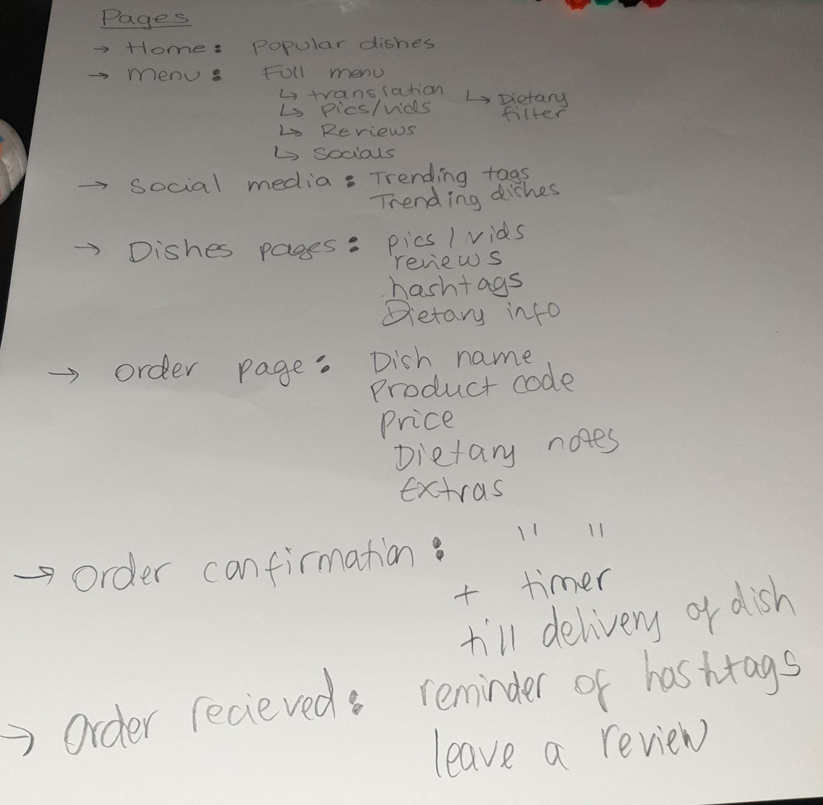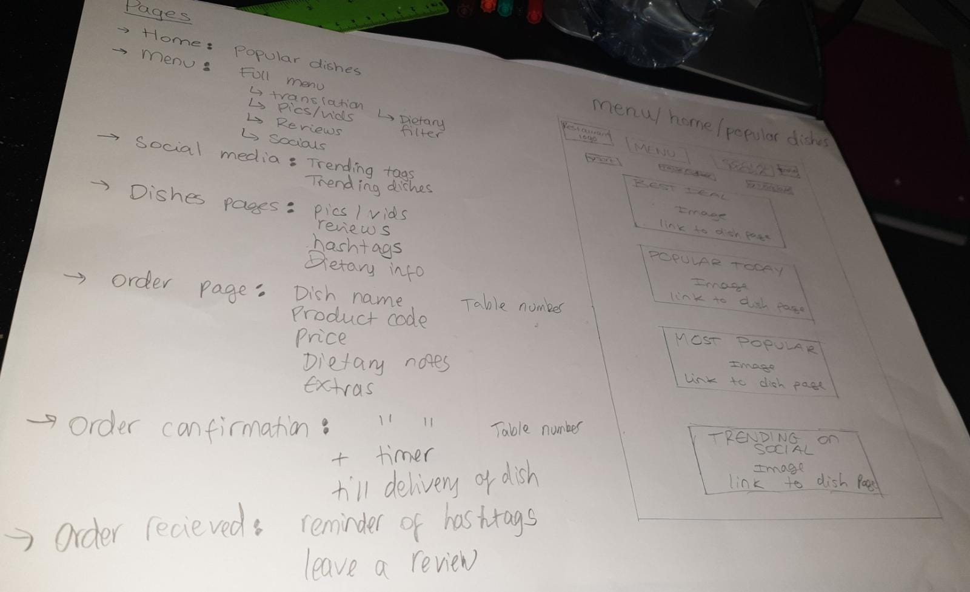

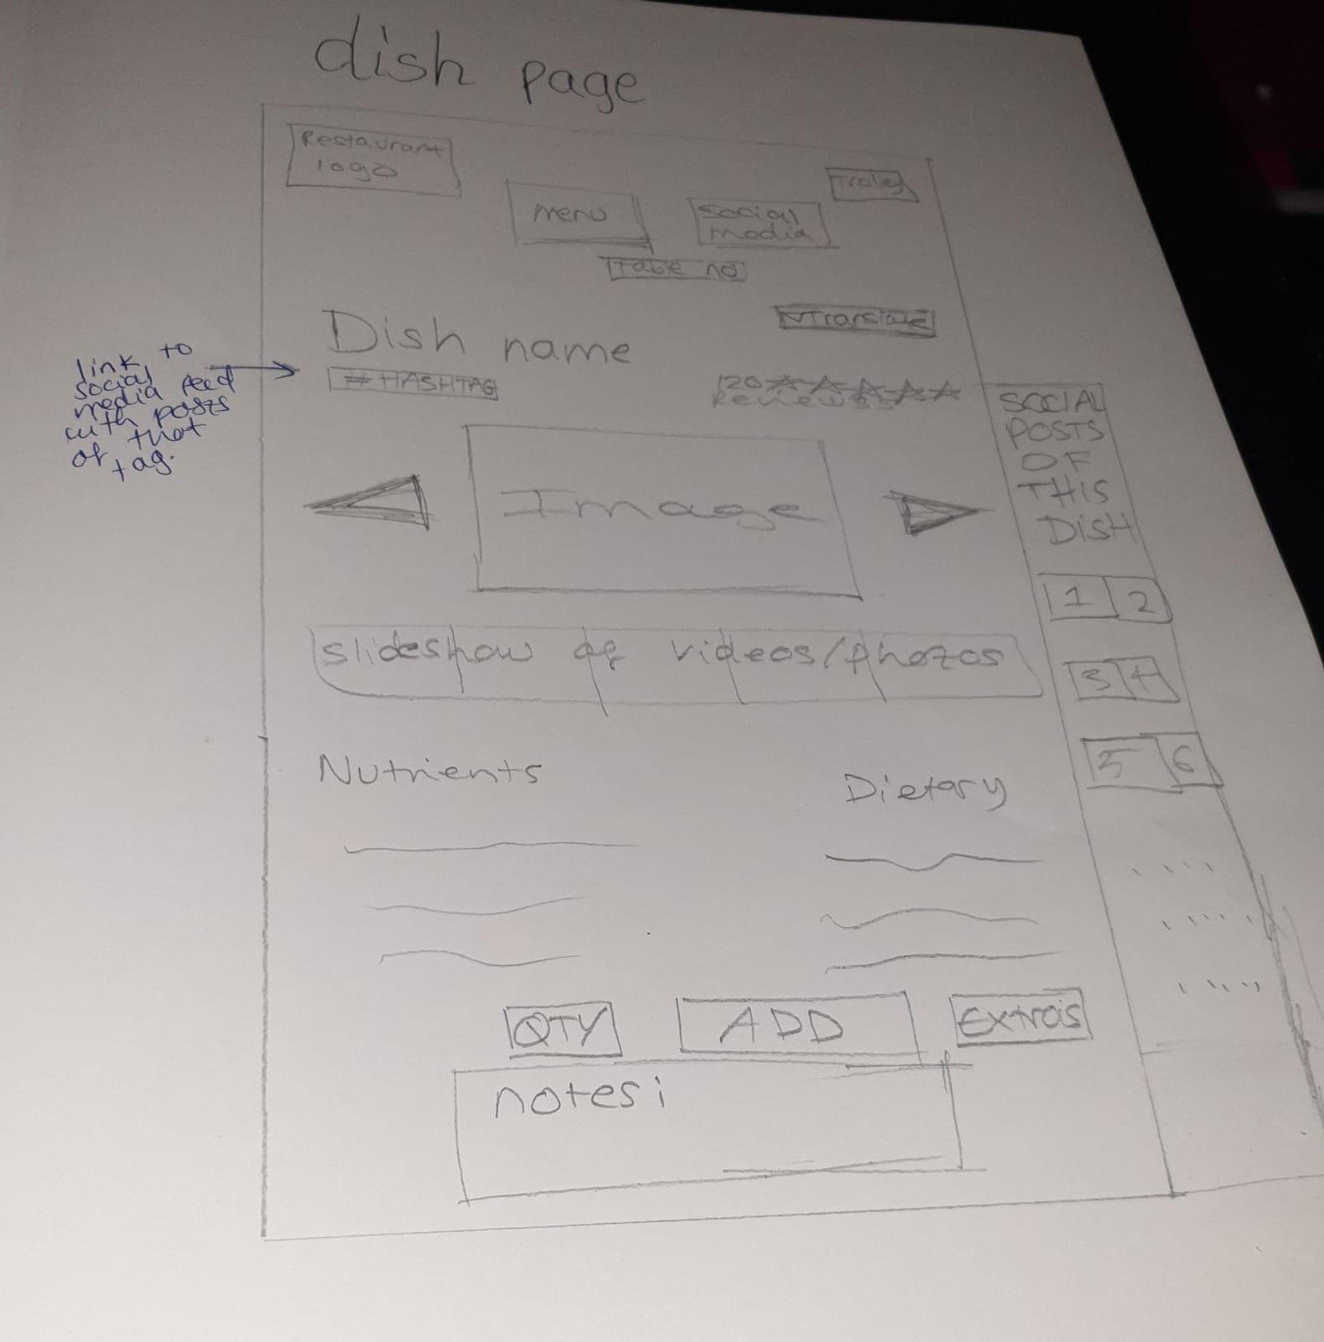

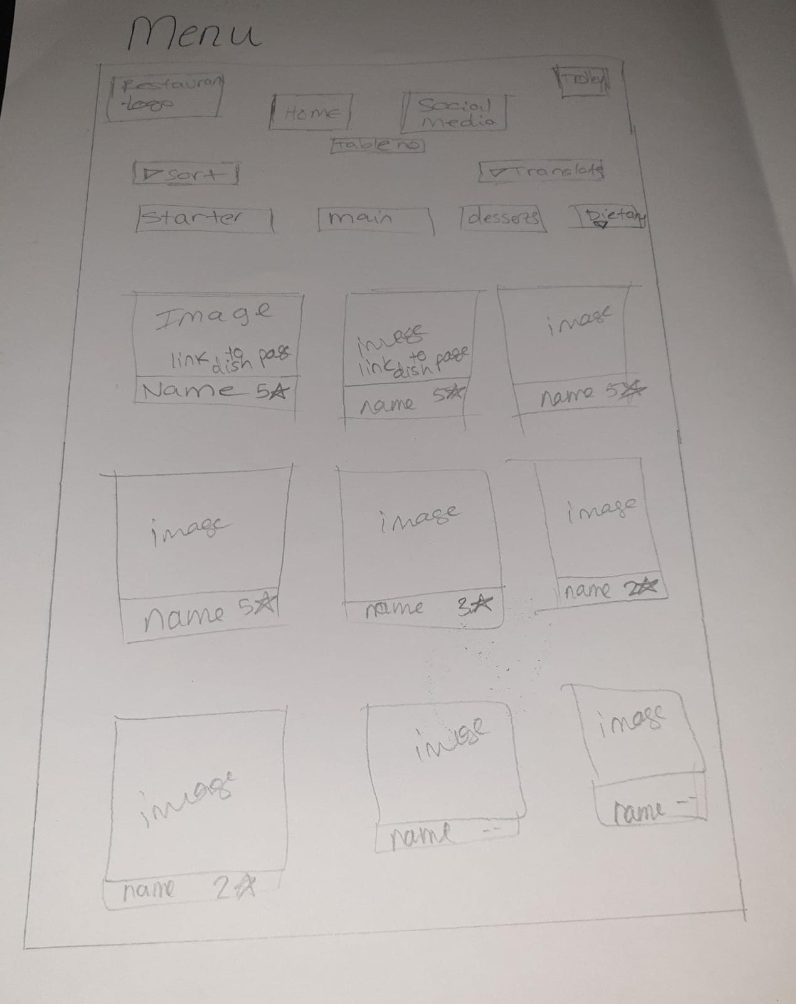

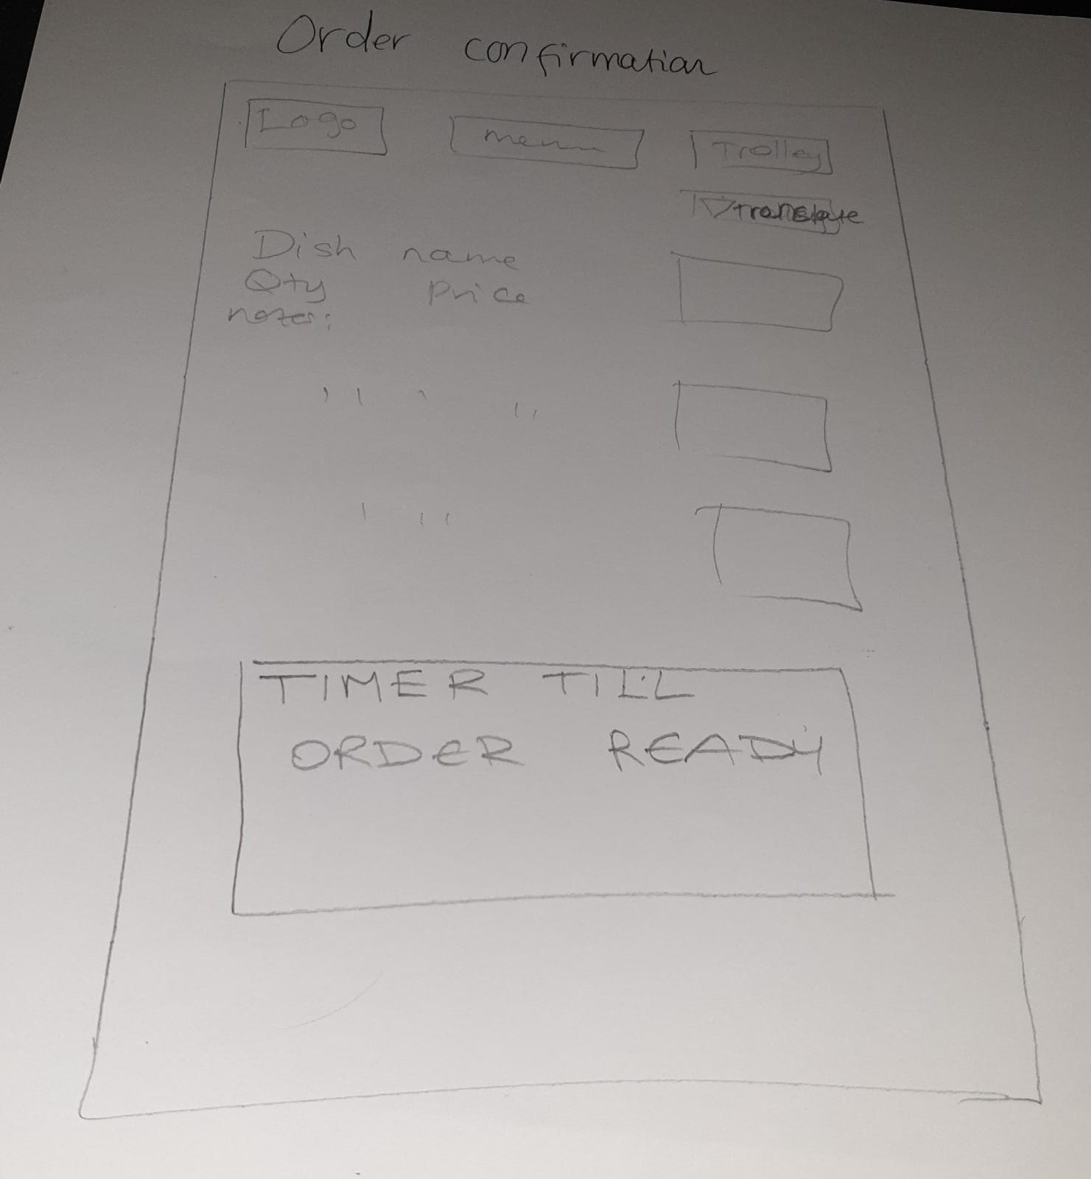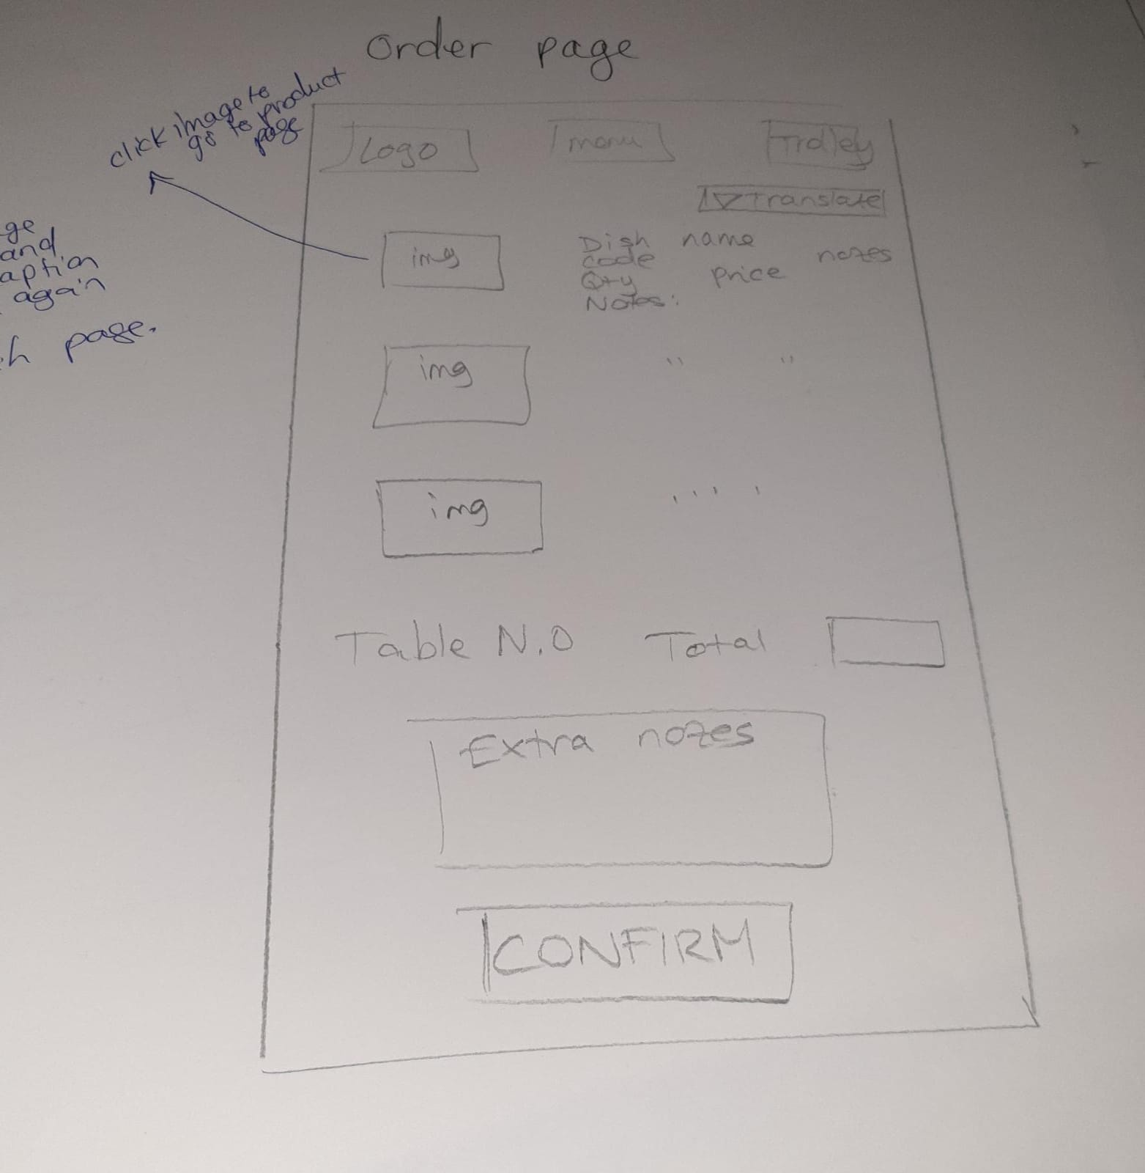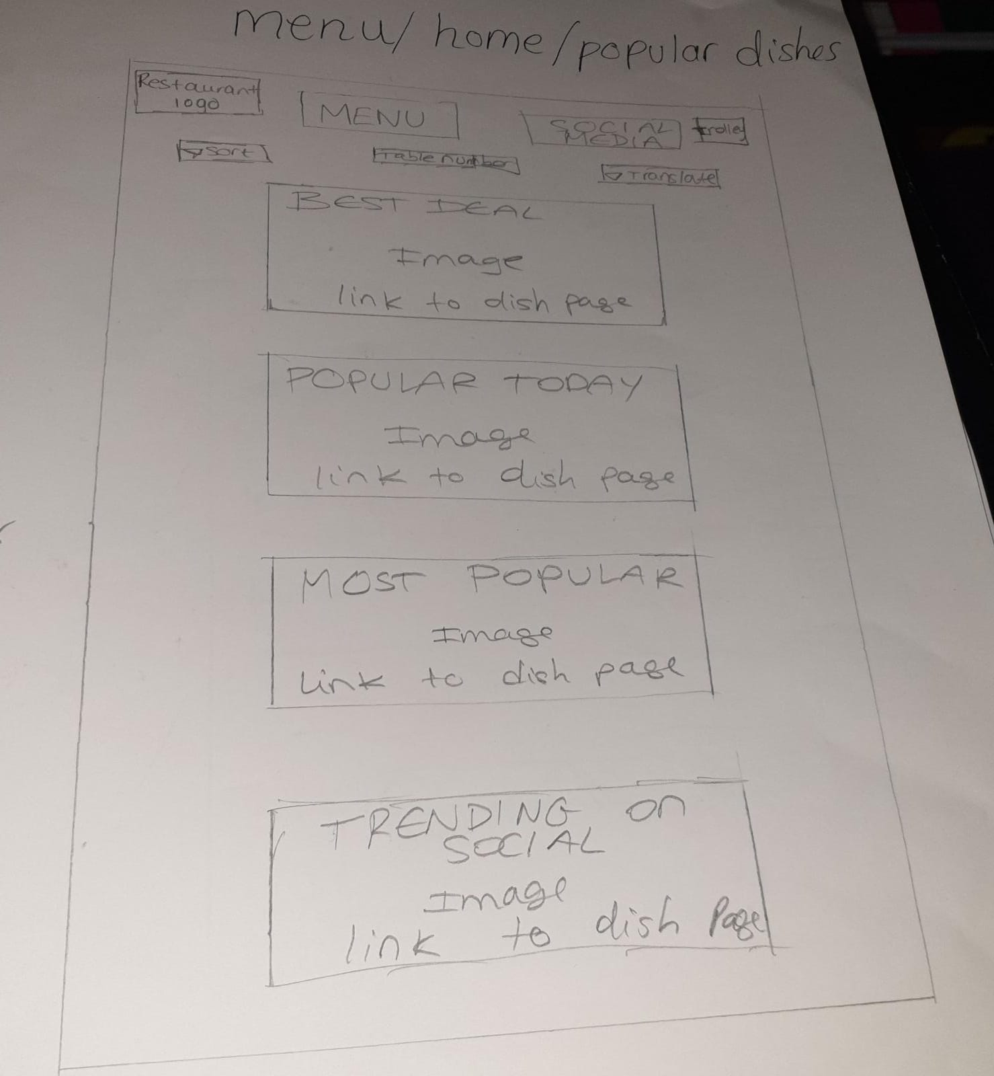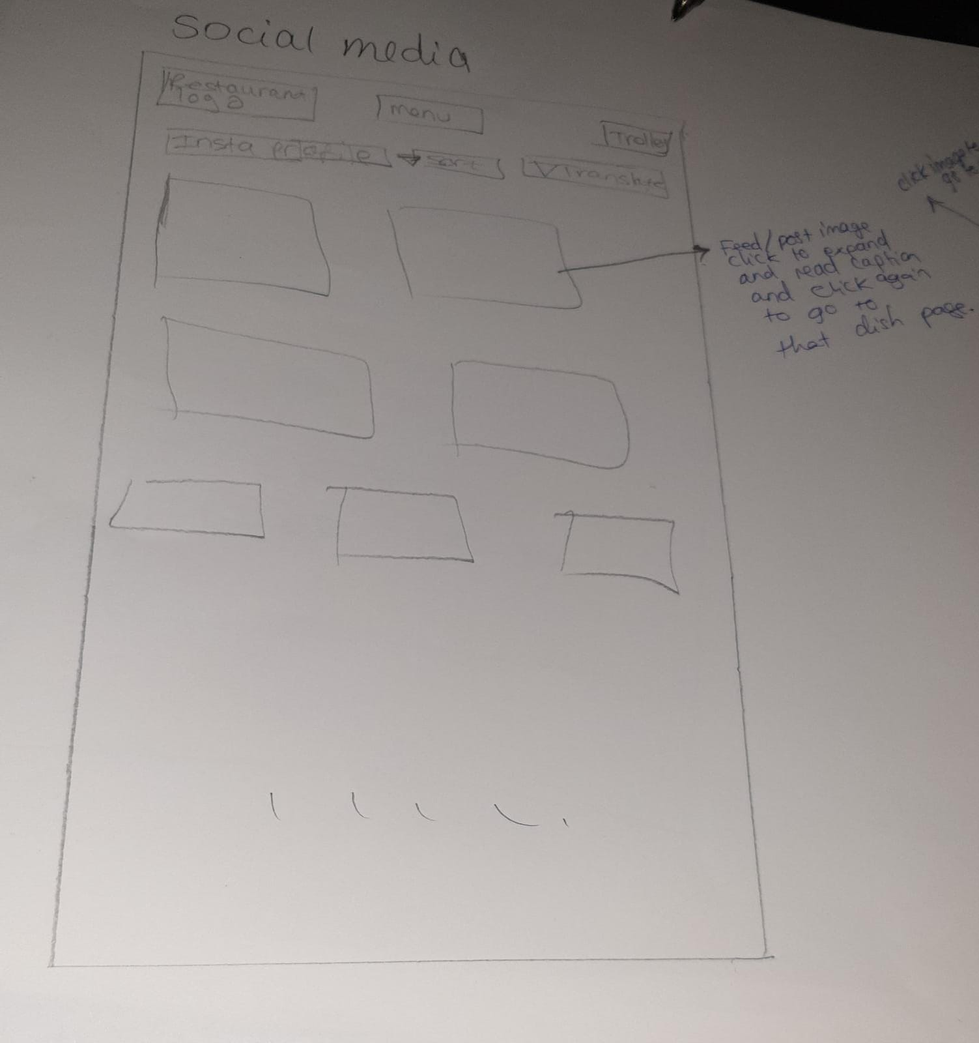

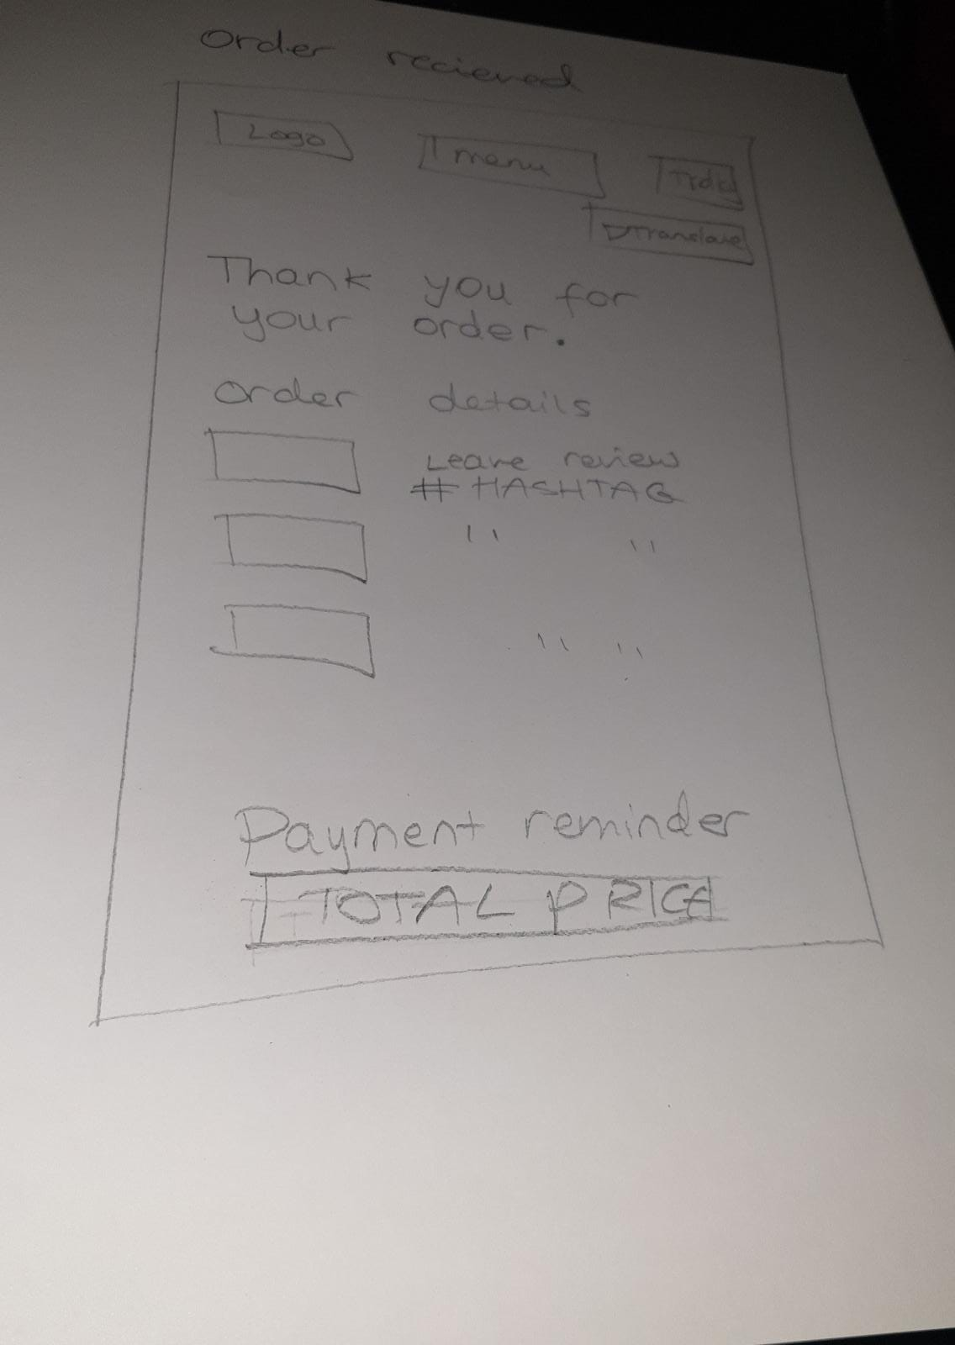

## 

## Low fidelity prototypes- chef side

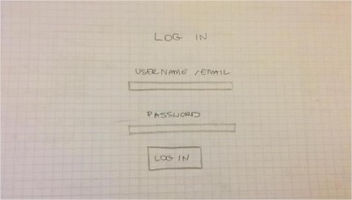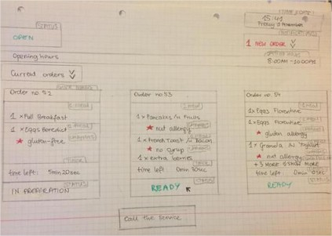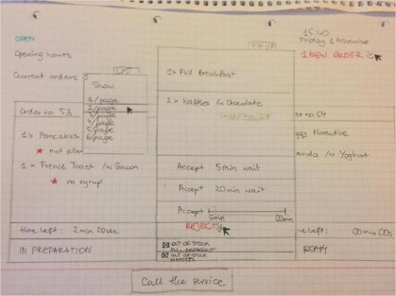

## Low fidelity prototypes- customers side

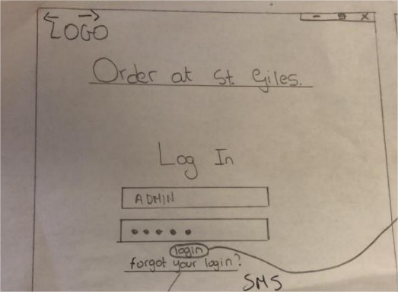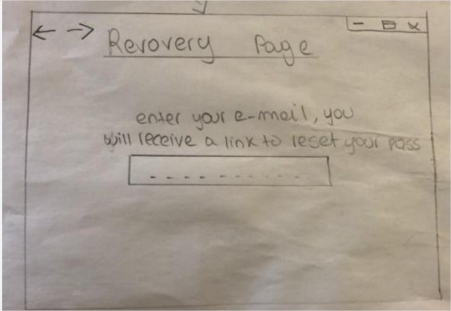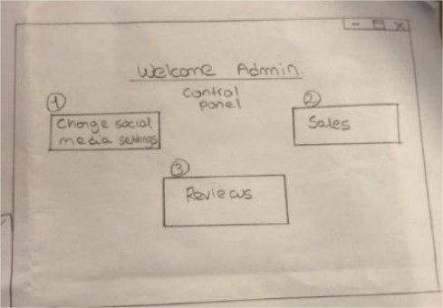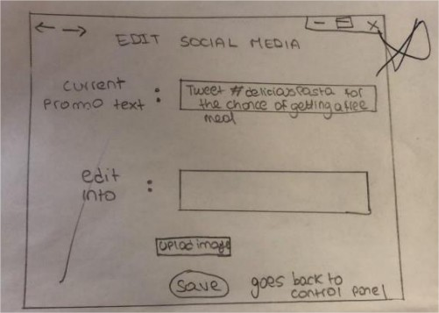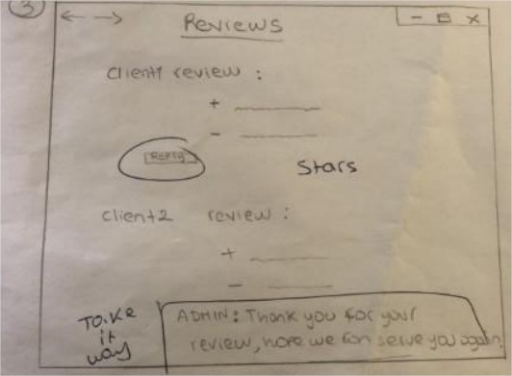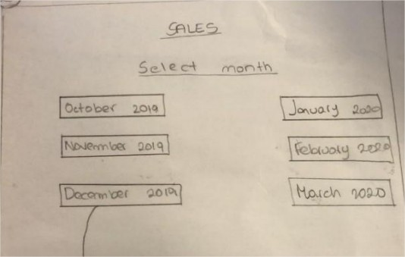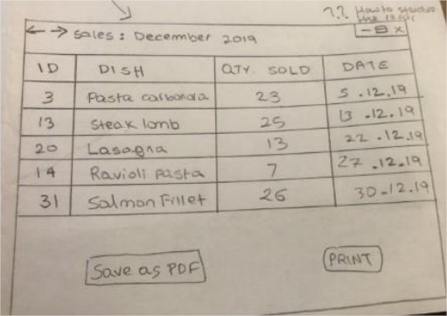

## Low Fidelity Meeting with SugarOverdose

Low Fidelity Prototyping Meeting & Feedback – Admin side

Meeting Script with SugarOverdose Narnia

Date: Monday 4th of November 2019

Meeting start time: 11:00

Meeting end time: 11:47

Subject: Low Fidelity prototype testing

Attendees: Bart Simpson (PM), Bugs Bunny, Steve Jobs and Frankenstein (Manager

from SugarOverdose Narnia)

The team has prepared low fidelity paper prototypes displaying in a visual manner for the

first time how the screens of the application can potentially look like.

Recap:

The interactive order system is composed of three main elements.

The client: a client can browse a menu, consult social media, order a dish and leave reviews,

visualise waiting time

The chef: the kitchen employers can visualise orders, increase order time, process the order.

Main feedback:

+ The client sees fit the ability of using simple reporting, client has suggested some

improvements for the tables and columns (to discuss further during high-fidelity meeting)

+ Admins encourage simple interface for managing data

+ The menu was very illustrative for the customers.

+ Social media feed is a perfect addition for our customers to explore.

Figure 7

- Admin concerned about password recovery with only Email, would like an SMS text to be

prompted password if Email is forgotten as well.

- The system initially had an option on the admin to respond to the reviews left by the users,

the client does not see fit this functionality, as clients are not likely in her long manager

experience to come back to revisit the response to a comment they made.

- The admin wishes to use reviews in this case only for internal business intelligence use.

This is also since they already implement Google's review system to get external reviews,

therefore, not efficient to have two different methods of gathering reviews.

- The translations opening page should have some flags to link to the language options.

- Some aspects are unclear now and can be judged only with high-fidelity prototyping with

some more functionality, the admin is curious to see how we can deal with reviews with an

extra layer of functionality

-The admin wishes to see how the social media aspect could benefit the ordering features.

This could potentially be revisited when the high-fidelity meeting will take place.

### Reflection on feedback:

The potential changes from the paper prototype meeting held on the 4th of November will

be incorporated into the high-fidelity subject to development and that will be logged in

upcoming section of this document. The process of feedback can potentially carry on even

after the meeting of high-fidelity prototypes with the client, in which case changes will be

made directly into high-fidelity.

The technical extent to which it is possible to incorporate SMS for password recovery will

analysed in later stages by taking consideration of scope, timescale and budget.

## High Fidelity Meeting with SugarOverdose

Attendees: Bart Simpson, Winston Smith

Frankenstein (Manager from SugarOverdose)

Meeting Start: 11:00

Meeting End Time: 12:29

Main point to consider in the agenda: High Fidelity Meeting with SugarOverdose

Main Feedback:

- [] Make the chef screen more clear

- [] The reviews should be left after they finished their experience

- [] Implementing an account, which in case they would be emailed the option of leaving a

review. Is it the first time for you here? Waiter helps them to build an account. Don’t want

it? Then there should be a general account

- [] Social media can be integrated as an optional choice into a separate screen, there are

business reasons behind this choice as it looks like you are trying to promote the brand

more than getting the customer to order

- [] Admin side needs a couple more features such as total revenue generation and some

sort of peak time data generation

- [] The current table in the admin sales shows if reviews are left or not, a more useful

information is to count the number of reviews in that field instead of Y or N.

(Not-technical) Open questions answered:

As a business are you afraid of negative reviews?

The manager is not afraid of negative reviews, they would see receiving negative reviews as

an opportunity as making things right and contact the customer through the review left.

This would give both the business and the customer to rectify any issues that might have

happened.

How close do you want your relationship with clients to be?

The business does wish to have a close relationship with the customers, but they do not

have the power to do it. Citing her words: ‘What would be the equivalent of Amazon

cookies for our business model?’

## Decision making: technologies relevant for the Interactive Order System

**Technologies involved in the creation of the Interactive Order System**

**Version 1**

Our team has decided to use a web application for our app over making a software application, due to the nature of our app being streamlined, smooth and client based. We want to make the web application easy for restaurant owners as there is no downloading needed so the web application can be up and running as soon as the page is loaded and easy for them to check all updates on their personal computers. We want to make the ultimate user experience for the clients, and we believe that HTML, CSS, JavaScript and MySQL will help us achieve this.

Our main function will be user experience and functionality. We want the clients to experience an easy to use web application with all the items on the menu easy to access from page to page. “JavaScript is very fast because it can be run immediately within the client-side browser. Unless outside resources are required, JavaScript is unhindered by network calls to a backend server. It also has no need to be compiled on the client side which gives it certain speed advantages (granted, adding some risk dependent on that quality of the code developed).[4]”

With this in mind, JavaScript was our top option for our web application, with its “predominant factor to shape highly interactive and dynamic web structures such as most celebrated Facebook, Twitter, YouTube and Gmail.

Developers can find it easy to develop apps using a range of JavaScript libraries and frameworks like Angular, Node, jQuery, and React.[5]”

JavaScript is also platform free, so business owners do not have to buy a certain piece of hardware for the web application to work. “Any JavaScript-enabled browser can understand and interpret JavaScript code. Any JavaScript code can be executed on different types of hardware a JavaScript program written for.[6]” We believed this was a big advantage especially for small business owners or for business owners just starting out.

JavaScript has been known for its huge libraries which will help us to pick and choose for our design, we are not limited to just one or two frameworks.

Our idea to have the application use social media as well means we must use back-end software as well. Our decision to use MySQL came from us handling relational data instead of dynamic data coming from all different sources.

From further research into back end databases, we wanted to also keep with our fast and efficient experience with our web application. MySQL showed us that it was able to provide all that.

“For web application, speed is critical, your user wouldn't wait your page to load, they just leave if your application don't responsive fast. The most common performance bottleneck is in database, select a high-performance database is very important.

Performance is vital for any database management system, under so many years of development, you can trust the performance of MySQL. The core philosophy of the design of MySQL is make it quickly get data in and quickly get it out, even it sacrifices some other important features, but if you are not very sensitive to those fancy features, the performance gain is worth it.

MySQL generally has better performance on simple queries we use every day, such as primary key lookups, range queries, etc.

MySQL performs well as the data size grows, from GB to several TB of data. The newest storage engine InnoDB, now the default engine for new tables, has been re-architected to take the advantage of multi-core systems.

MySQL also provides query cache and main memory table to take advantage of today's hardware with large amount of memory resources.

Guide.freecodecamp.org. (2019). *Advantages and Disadvantages of JavaScript*. [online] Available at: <https://guide.freecodecamp.org/javascript/advantages-and-disadvantages-of-javascript/>

[Accessed 11 Dec. 2019].

2 Redbytes: Custom Mobile Application Development Company [iOS, Android, Windows]. (2019). *15 Best Programming Languages For Mobile Apps 2019 | Redbytes*. [online] Available at: <https://www.redbytes.in/best-programming-language-for-mobile-apps/>

[Accessed 12 Dec. 2019].

3 Spencer, J. (2019). *Top 9 Advantages of JavaScript*. [online] MarkupBox. Available at: <https://www.markupbox.com/blog/advantages-of-javascript/>

[Accessed 12 Dec. 2019]

**Impactful supervisor meetings**

## Supervisor 12/11/2019

Attendees:

Bart Simpson

Wilma Flintstone

Winston Smith

Beginning: 11:27

End: 12:01

Points covered:

* The supervisor has received a preview of low fidelity prototypes and high-fidelity prototypes
* The supervisor expressed some opinions about how a promotional code could be used separately for a discount
* Talks about the marking and the feedback of M3
* Attendance to be reinforced
* Reinforced the importance of e-mails. Emails can be used for all sorts of marketing purposes. This relates to the fact that the client wishes to have phone numbers as well as a way of recovering passwords.

11:27 - 11:37

Discussion about customer prototyping (high fidelity and low fidelity)

11:37 - 11:45

Discussion about both chef and admin aspects

11:45 - 12:00

Supervisor checking potential arising issues and team commitment.

## Supervisor meeting 15/10/2019

* Admin
  + Progress tracker, no deadline, we are ahead with prog 1 and working on 2
  + Trello done - 3 tabs for tasks
  + Backlog is being maintained
  + Moving from google drive to Igor and using a physical copy
  + Moving to Moodle chat
* Market research
  + Stories have been developed
  + Called restaurants, i.e. PunkRockers
  + Competitor apps with pros and cons list
  + Will be visiting sushi restaurant which has tablet in table
  + Talk to clients, managers and google answers
  + Scaling
  + Define features from competition and then decide which you need or want
  + Each feature will need a budget time
  + Start a table on how to do features, clear instructions
  + Atomic, testable, realist
  + Phase features in non-tech talk

Try by the end of this week to define features

To-do list:

* Calls need to be arranged
* New stories need to be found
* Template for features
* Template asking questions

## Supervisor meeting 29/10/2019

Attendees:

Bart Simpson

Steve Jobs

Wilma Flintstone

Tony Blair

Bugs Bunny

Beginning: 11:36

End: 12:00

Points discussed

* Decision making for prioritising technologies involved
* Production of spread-sheet document to ID features and to update as the project progresses.
* Discussion on how to implement different milestones to manage the 4 weeks long milestone to deliver M4
* Decision on how to split the design aspects and role assignment.

1. For further Design Decision information refer to the Low Fidelity and High-Fidelity meeting script and feedback in the Appendix
2. For further Design Decision information refer to the Low Fidelity and High-Fidelity meeting script and feedback in the Appendix
3. For further Design Decision information refer to the Low Fidelity and High-Fidelity meeting script and feedback in the Appendix
4.
5.
6.